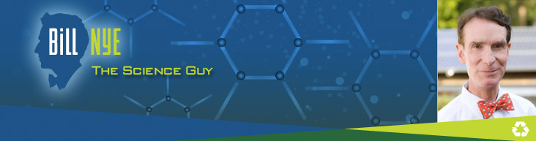
I’m Bill Nye
A Science Demonstration Project
Inspired by Bill Nye!

Name: ___________________
Idea for Demonstration (explain what you plan to do):

Source(s) for your idea – website address(es), books, people:

Materials (explain what you will need):

Science concept being illustrated (density, chemical reaction, pressure, light or sound):

What tie-in to the real world does this have (why might this be important or helpful to know)?

Explain what happened/will happen in your demonstration and why:

Plan to make a change to your demonstration; predict what effect might result from the change and test your theory:

