Wilma Jean and the Worry Machine
by
Julia Cook
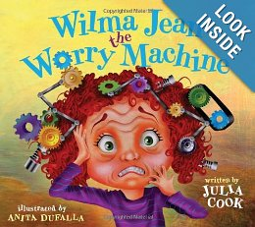
Wilma Jean can’t get out of bed because she has what she calls, the worry flu. Wilma Jean is a worrier – much like some of our gifted and talented students are. She worries about everything – much like some of our gifted and talented children do. According to Wilma,

“My tongue gets salty,
My throat gets tight,
I grit my teeth
Cause nothin’ feels right.”

Wilma suffers from a “what if” syndrome. What if the kids laugh at her new hairdo? What if she misses the bus and is late for school? What if she solves an addition problem incorrectly in front of her entire class? What if she strikes out during softball practice? What if carrots are being served in the café?

We have focused on anxiety, stress and perfectionism in previous book studies and with students during Lunch Bunch/Recess Rap. We feel it’s important to revisit these topics in “kid-friendly” form because anxiety has a way of spreading and shifting in form.

Wilma Jean and the Worry Machine is a fun and creative book that relates to children of all ages. Use the story to initiate conversations about stress and anxiety in our everyday lives. The follow-up activities may provide children with potential tools to use should they feel a need to be in control of their anxiety.

Related Resources:
When My Worries Get Too Big by Kari Buron
David and the Worry Beast by Anne Marie Guanci
What to Do When You Worry Too Much by Dawn Huebner
The Worry Glasses Overcoming Anxiety by Donalisa Helsey

Activities:

- Worry Rocks
  - Materials
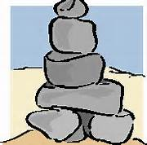
    - Various sizes of rocks ranging from the size of a tangerine to the size of a pebble
    - Small disposable cup
    - Water
    - Strips of paper
    - Pencil and/or markers

  - Directions
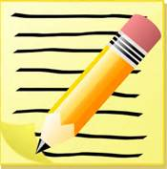
    - Using strips of paper, have children write down all the things they are worried about.
    - Have them separate rocks into three piles by size. (small, medium, large)
    - Children then divide up their worry strips into three categories, similar to the rock piles. (Small Worries, Medium Worries, Large Worries)
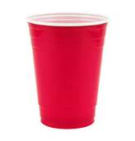
    - Fill the cups half full with water. The water represents all of the stuff that they have going on in their lives, and the rocks represent the worries.
    - For each worry, have children drop the right sized rock into their cup. If their cup flows over, they have too many worries. Have them re-examine their worry strips and work on removing some of them through logical thought and realistic evidence. They may also end up needing to remove worries over which they don’t have control such as the weather.
    - Children should see firsthand that if you have too many small worries in your life, you won’t have room to deal with your bigger worries.
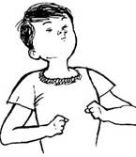
- Square Breathing
  - Materials
    - Paper and pencil
Directions: Draw a clockwise square as you breathe in and out. Start in the bottom left corner of your paper. Slowly inhale as you draw a line up. Hold your breath as you slowly draw a line across to the right. Exhale slowly as you draw a line down toward the bottom of the paper. Pause your breathing as you draw a line to the left completing the square. The bigger the square, the slower you breathe.

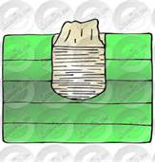
- The Worry Monster
  - Materials
    - An empty tissue box
    - Construction paper
    - Markers
    - Scissors
    - Glue
  - Directions
    - Decorate an empty tissue box to resemble the head of a monster. Make the opening of the box a mouth by gluing teeth around the edges. This is the worry monster that will eat problems away.
    - Have children write down what they are worried about on small strips of paper. Have them feed the worry monster by placing their worries into his mouth.
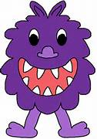
    - Frequently check and remove the worry strips, monitoring each worry situation individually. Intervene when needed.

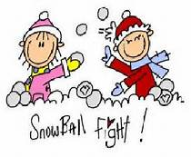

- Worry, Worry Snowball Fight
  - Materials
    - White paper
    - pencils
  - Directions
    - Each participant should get two pieces of paper.
    - Everyone should fill both sheets by writing down all of their worries.
    - Wad up the papers into tight balls.
    - Have a “snowball” fight with the papers.
    - At the end of the snowball fight, collect all of the worry snowballs, put them into a bag and recycle!
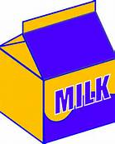
- Magic Worry Milk
  - Materials
    - One 9” by 3” clear glass baking dish
    - Whole milk
    - Food coloring
    - Liquid dish soap
  - Directions
    - Pour enough milk in the pan to cover the bottom. (This represents a person.)
    - Using the food coloring, create any design. (Each color stands for something that is happening in your life or something that needs to be accomplished.)
    - Aim the dish soap at the center of the pan and allow two to three drops of dish soap to fall into the milk. (This represents the anxiety.)
    - Do not stir.
    - Watch as the milk starts to swirl and the colors start to travel and mix until they eventually become unrecognizable. (This represents what anxiety does to a person. Anxiety churns and mixes everything up – making it harder for a person to recognize what is going on and what needs to be accomplished.

- Worry or Unworry? Which Side am I on?
  - Materials
    - Stack on index cards
    - Paper
    - Pens/pencils
  - Directions
    - List every worry you have, no matter how big or how small on the pieces of paper.
    - Fold the index cards in half vertically.
    - Write down one worry on the left side of each index card. (use as many cards as needed)
    - Take one worry card and think of an “unworry” or two that could be written on the right side of the index card. An explanation of how to get rid of the worry should be included.

Examples
Worry
I am worried about my math test.

We might have a tornado.

I think my parents might get divorced.

“Unworry “
I will study for it every night this week. I will ask my teacher for practice problems to help me get ready. I will come prepared!

I cannot control the weather. I have a tornado safety plan in place. The logical chance of having a tornado today are very slim.

I did not cause this, I cannot control this, so I have to learn to cope with it. I can only worry about the things I can control.

- What Are They Worried About?
  - Materials
    - Magazines
    - Poster board
    - Markers
    - Glue
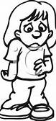
“I am worried about telling my parents that I broke the window when I was fooling around.”

  - Directions
    - Look through magazines and cut out the faces of people who look worried or anxious. Glue the faces to the poster board. Below each picture, write a caption telling what the person is worried about and why.
    - Choose your favorite face and caption, and creatively write a story about the picture. Include answers to questions such as:

- Why is the person worried?
- Is there anything the person can do about the worry?
- Is this a worry that they can control?
- What is the person planning on doing about the worry?
- What can the person do to help control his/her worries?
- Stick It to Your Worries
  - Materials
    - Wide craft sticks
    - Fine tipped marker
    - Container
    - Paper and pencil

  - Directions
    - Brainstorm strategies that may control or reduce anxieties. The strategies can be for you or for someone else.
    - Write each strategy on a craft stick.
    - Place all the sticks in the container.
    - When feeling anxious or worried, “stick it” to the worry by pulling a stick from the jar and following the suggestion.
    - Don’t worry if the first strategy doesn’t work – just try another one.

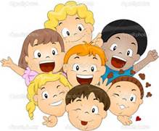
- Possible Strategies to Include (Use what you think would work best for you!)
  - Talk to someone who will really listen to what you have to say.
  - Approach a feared situation one step at a time until it becomes familiar and manageable.
  - You are not alone. Lots of kids worry about school, parents, friends, sports and family.
  - If you don’t understand something, don’t be embarrassed to ask for help.
  - Share your scared feelings with a parent, friend counselor, teacher – someone you can trust and respect.
  - Remember that no one is perfect. You can’t be the best at everything.
  - Feel proud each time you try your hardest.
  - To keep your worries from growing too large, picture a big, red stop sign in front of you. Stop at the sign and think for a few minutes about our problem.
  - Listen to soothing music, take a walk, look at the clouds, practice deep breathing, etc…
  - Visualize yourself doing something great!
  - Always plan to be on time or early.
  - Do everything you can to prepare for an event or situation.
  - Don’t expect yourself to be anxious. Tell yourself you will be fine.
  - Role-play strategies and how to react in certain situations.
  - Concentrate on your personal strengths.
  - Organize your school supplies for the next day the night before.
  - Try harder to do things on your own.
  - Ask your teacher to allow you a little extra time on tests.
  - Designate a “safe” person at school that understands you. When you need to, go and talk with that person.
  - Don’t let other people’s fears become yours.
  - Work together as a team.
  - Don’t use your anxiety as an excuse to get out of things that you are able to do.
  - Walk away from your situation and take a “mental vacation” for a few minutes.
  - Have reasonable expectations about yourself.

Cook, Julia, Wilma Jean and the Worry Machine. Chattanooga, TN: National Center for Youth Issues, 2012.
