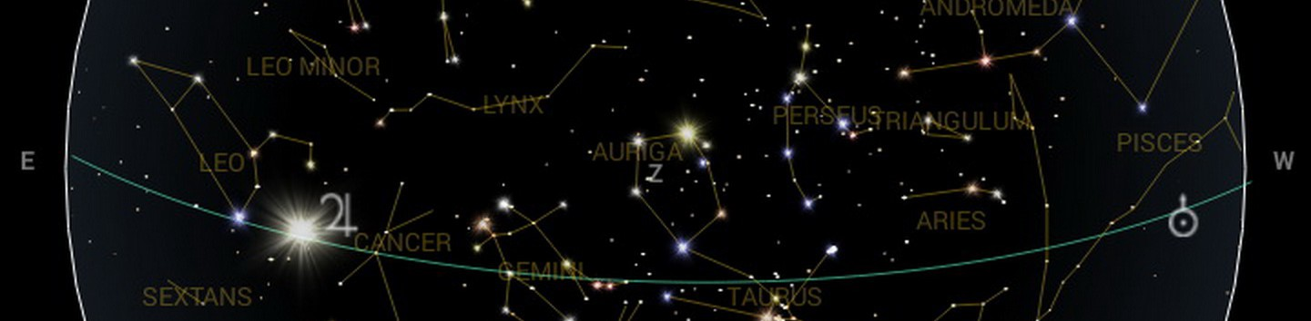
Astronomy Choice Project

You have made it! All of your hard work this year is really paying off. You have shown proficiency in measurement, making observations, team work, design, being able to research, organize information, communicate ideas ( in graphs, diagrams, and written descriptions), show connections and relationships, analyze information, justification, classification, inferring, and prediction, among others that we use in Science and our daily lives.

You are going to direct your learning to an Astronomy topic of your choice. When you are finished this will be displayed in the hallway for others to learn from as well.

Requirements:
This should be research based. Factual. Use credible sources. Have a spot where you display the sources you have used.

Title is easy to read. Stands out from the other text.

This project should demonstrate your learning. Explain the topic in terms your peers would understand. Use words that people your age would know. Be careful that you do not plagiarize. If you don't know what something means, look it up! Explain in your own words.

Make connections to other aspects of astronomy, your daily life, or the future. Why is learning about this topic important?

Should be visually appealing. Writing that is large enough for people to read. Should have writing that teaches someone about your topic. NOT a collage of pictures. Think about what grabs your attention.

Planning:
On a separate piece of paper write out the following...
Choice Topic :
I am choosing this topic because:
Three questions I have about this topic (not yes/no questions):
My plan for this project is...(can be a written description or draw a picture of what you want it to look like)

End of project: evaluation
Choice topic:
Three things, or more, that you learned:
Written work on project is in my own words, my own explanations
I have taught about my topic (list)
I have designed my project in an interesting, organized way
Sources sited included on project (Yes No)
Visuals included (charts, diagrams, models, graphs etc)

