Gravity’s effect on
Name:
Hour:
Learning Target: I can explain how the mass of an object affects the gravitational attraction between objects.
gravitational attraction between objects.
Definitions:
Mass: the measure of the amount of matter that something is made up of; remains constant regardless of location
Gravity: The force that pulls two bodies together; increases as the size of the body increases
Weight: Force on the gravity of an object; relative to the mass of an object; changes based on the gravity

Gravitational Pull
Weight is the force gravity exerts on an object due to its mass. Mass, roughly, measures an object's inertia, its resistance to being moved or stopped, once it's in motion. Your mass remains constant across the universe, while your weight changes depending on the gravitational forces acting on you, which vary from planet to planet.

Newton's Law of Universal Gravitation says that everything that has mass attracts every other thing that has mass, pulling with a force (a) directly proportional to the product of the two objects. However, gravity decreases exponentially as the distance between them increases. When calculating surface gravity, that distance refers to the space separating you (on the surface) from the planet's center of mass. This means that a planet's size actually has a greater relative impact on its gravity and on your weight on its surface than does its mass.

Challenge
You are a space traveler… a super good one. So amazing, that you travel to all of the planets in the solar system. Having a $3 billion dollar space suit, personal rocket-ship, and eternal youth makes this easier for you. There is one catch though, you want to make sure you are wearing the right shoes for each planet; you see, your shoes are sensitive to gravity. You have 3 pair: the Nike’s can only be worn when your weight is less than 30, the Adidas can only be worn when your weight is between 31 and 120, and the Air Jordan’s can only be worn when your weight is bigger than 100. Using the following formulas and data, which shoes should you wear on each planet?

Mass &Weight
Formula:

My Weight
X Gravitational Proportion
My Weight on other Planet
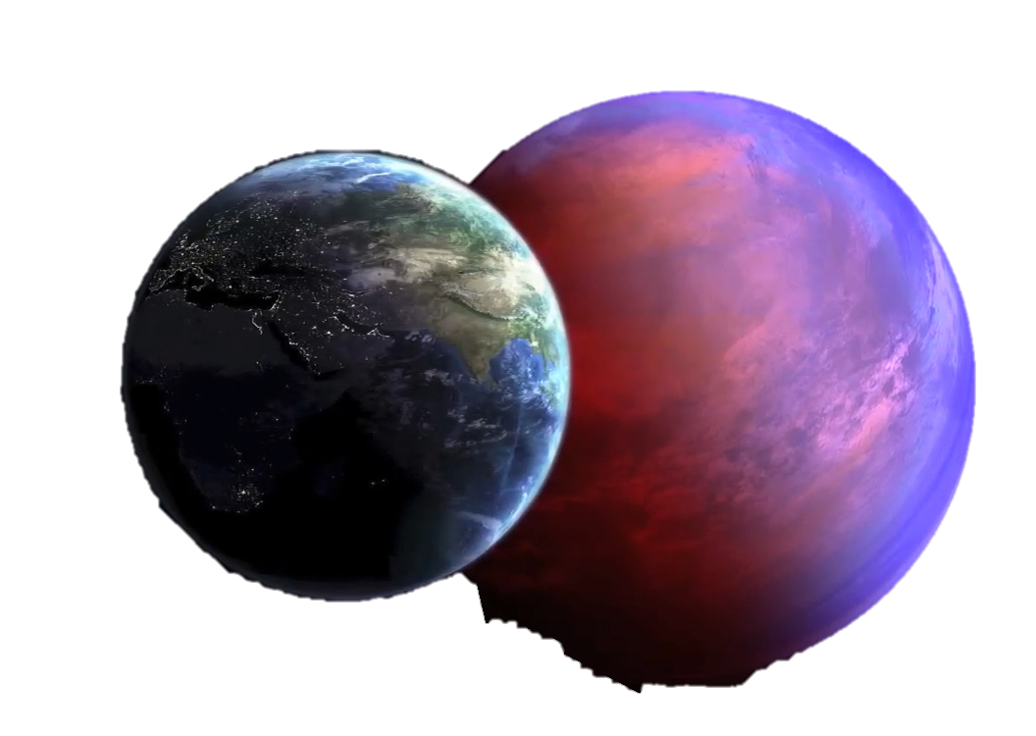
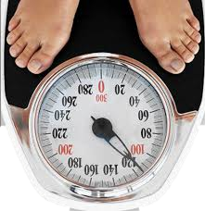
Planet | Gravitational Pull Compared to Earth | My Weight in pounds on Planet | Shoes
Mercury | 0.38
Venus | 0.91
Moon – not a planet | 0.16
Mars | 0.38
Jupiter | 2.36
Saturn | 0.91
Neptune | 0.89
Uranus | 1.12
Pluto– not a planet | 0.06

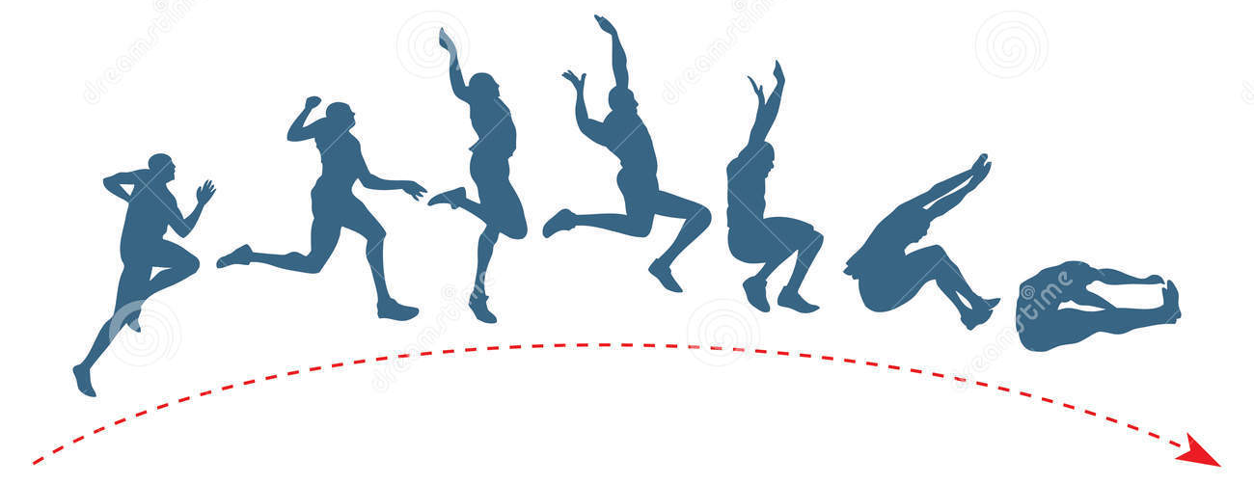
How far could I jump on another planet?
Determine how far you can jump on the Earth. To do this, place a piece of tape on the floor as a starting line. Jump as far as you can off of both feet. Have your partner mark where you land not where you end up! Measure the distance and record in the table. Do this five times, then find the average.
Trial 1 | Trial 2 | Trial 3 | Trial 4 | Trial 5 | Average

Now it is time to get on your space shoes and see how far you can jump on each planet…
Planet | Gravitational Pull Compared to Earth | My Jump distance on other planet
Mercury | 0.38
Venus | 0.91
Moon – not a planet | 0.16
Mars | 0.38
Jupiter | 2.36
Saturn | 0.91
Neptune | 0.89
Uranus | 1.12
Pluto– not a planet | 0.06

Formula:

Average Jump
÷ Gravitational Proportion
My Jump on other planet

Complete each statement:
A person would weigh more on ____________ than on _____________, because___________________________
_______________________________________________
A person could jump further on _____________ than on _______________, because ________________________
_____________________________________________________________________________________________
The force of gravity between two objects depends on _________________________________________________
_____________________________________________________________________________________________

