You are going to need headphones and be at your assigned lab station.

When you are done with class today, you should be able to
1. Give examples of the function of stems.
In 1872, a trained forester, William Ferguson, reported a fallen Mountain Ash, which was 18 feet in diameter and 435 feet long.

2. Explain the function of Xylem and Phloem tissue.
What is xylem and phloem? https://www.youtube.com/watch?v=jtuX7H05tmQ

How does water get from the roots to the leaves? Transpiration and Xylem http://viewpure.com/Kv_0udatlh8?ref=search
http://viewpure.com/mc9gUm1mMzc?ref=search
The world’s tallest living standing hardwood tree, is a Mountain Ash named Centurion which is located in Tasmania, Australia. It is approximately 329 foot 8 3/4 inches tall.

In 1964, after his coring tool broke and getting permission from the U.S. Forest Service, a research scientist to get an accurate age measurement cut down a Bristlecone Pine, in Great Basin National Park, since named Prometheus! It turned out the tree was over 4,950 years old making it older than the Bristlecone Pine named Methuselah, which at the time was 4,803 years old. He had not only found the oldest living thing on the planet, but he had also killed it. A cross-section of the tree is on view at the Great Basin National Parks, visitor center in California.
How does food (glucose) move to parts of the plants that need it. (2:19) Phloem http://viewpure.com/QXdujo4PZ7c?start=0&end=0
Xylem and Phloem song http://viewpure.com/akxITsMb0Jw?start=0&end=0#
The tree with the widest {diameter} tree trunk in the world is an African Baobab. Its trunk diameter is almost 49 foot, it has a circumference of 155 foot and is 72 foot tall.

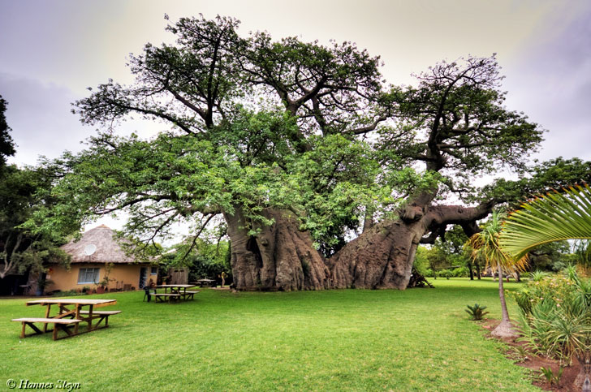

What do the dark and light layers of a tree ring tell you? http://viewpure.com/IG44MW_iMmI?start=0&end=0
What does the thickness of the ring tell you?
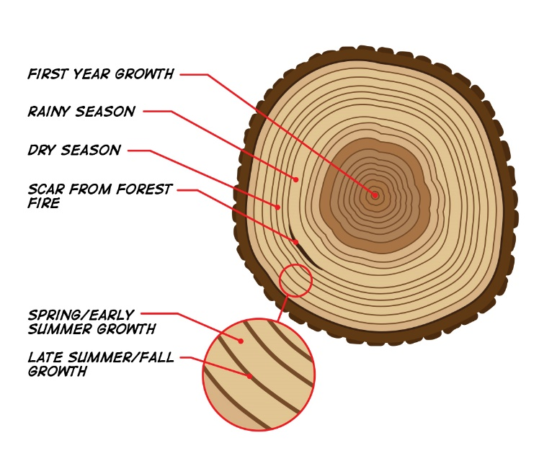
After you have watched these videos and are able to answer the questions above, check out the tree stem samples in class. Use a magnifying glass (hand lens) to help you see clearer. How old are the trees? Why are some of the rings narrow and others wide?

What can you learn from tree rings? http://viewpure.com/vtK7w4F5GW0?start=0&end=0
How do tree rings tell about climate in our history? http://viewpure.com/T391URPJVT0?start=0&end=0

