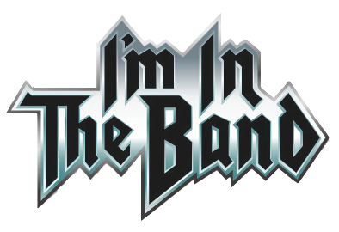
My name ___________________________________
This Photo by Unknown Author is licensed under CC BY-SA
Different types of music I would like to sing:
1.
2.
3.
4.
5.

Songs I would like for my group to use for this project:
1.
2.
3.
4.
5.

Topics I would like to sing about: What I would like our dream stage to look like:
Check the ones you are interested in. Sketch your ideas in the box below

Earthquakes
Volcanoes
Plate tectonics
Minerals
Rock cycle
Boundary type
Convection
Earth’s layers
Other: please list
Other: please list

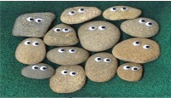
This Photo by Unknown Author is licensed under CC BY-SA

What I would like our dream stage to look like:
(make it look like a rock star, include an
instrument you would like to “play”)
Sketch your ideas below.

Ideas for the band’s name: (must be rock related)
1.
2.
3.

