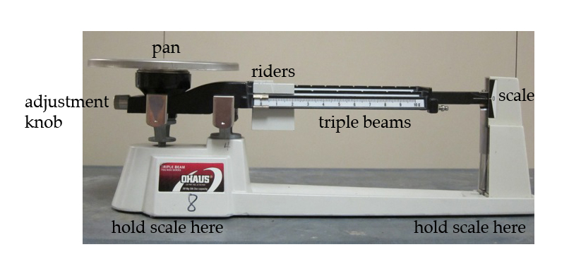
LT: I can accurately measure mass to the nearest g and mg.
Measuring Metric: Mass

Problem:
- Make sure that all of the riders are all the way to the left, at the zero mark, and check to see that the pointer is pointing at zero. Then your balance is balanced! If not, ask your teacher for assistance.
- Lift and move the rider along the beam making sure it is securely in a notch. Start with the 100g mass. Next use the 10g mass, followed by the 1mg mass.
- Find the mass of at least 3 objects. Record the object and the mass in Table 1 below.

Object

mass (g)

Observations:
Table 1: Mass of objects in grams
