Educational Games Online

Objective: The objective of this class is to introduce the students to all of the things that a computer can do. The programs are divided into seven categories. The students are introduced to programs in each category based on prior knowledge and interest. Not all programs may be used in a given session. The programs that the students have been exposed to are on the list that accompanies this note. Links are provided where possible and are subject to change. If a given link does not work try a Google search using the program’s name.

Virtual Reality

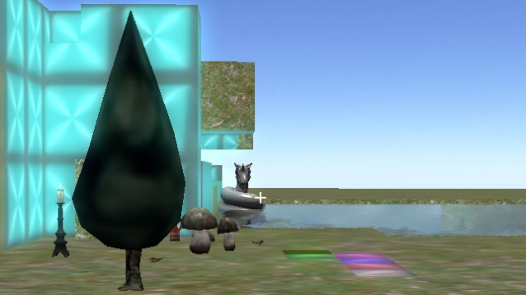 **Platinum Arts Sandbox:** This program allows students to create a virtual world and walk around inside of it. Cost: $0.00 Free Download

<http://www.sandboxgamemaker.com/>

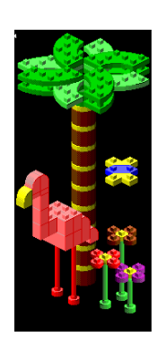**Gryphon Bricks** is a virtual construction toy for the entire family. The Lego-style building set gives you the power to create anything from your own space station to a futuristic concept car. Gryphon Bricks stimulates the imagination and offers two different interfaces: one to suit the little ones and one for grown-ups. The children's version features easy-to-click buttons and cool sounds associated with the various functions; the "big kids'" version offers similar features but includes more sophisticated functions, such as multiple view options and the ability to print blueprints of real-world models. This software is out of date but was owned by the school back in the 90’s.

**[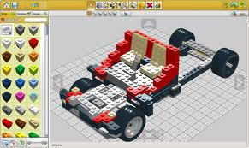](http://www.google.com/imgres?q=lego+digital+designer&safe=active&sa=X&biw=1280&bih=927&tbm=isch&tbnid=0DYTdcVEo3mkfM:&imgrefurl=http://lego-digital-designer.softonic.it/&docid=UrVGh_Rvir9r4M&imgurl=http://screenshot.it.sftcdn.net/it/scrn/37000/37451/lego-digital-designer-5.jpg&w=700&h=417&ei=sDPUUaTAJom2rQHeiID4CQ&zoom=1&ved=1t:3588,r:18,s:0,i:135&iact=rc&page=1&tbnh=173&tbnw=291&start=0&ndsp=20&tx=203&ty=120)Lego Digital Designer**

**Build your world with many virtual Lego bricks. Cost $0.00**

<http://ldd.lego.com/en-us/>

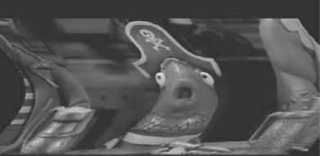**Productivity**

**Video Pad Editor**: Designed to be intuitive to use, Video Pad is fully featured video editing program for creating professional looking videos in minutes. Making movies has never been easier. Cost: $ 0.00 for Basic -[$69.95 Master Edition.](http://www.nchsoftware.com/videopad/index.html)

<http://www.nchsoftware.com/videopad/index.html>

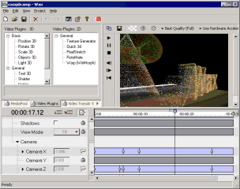

**Wax** is a high performance and flexible video compositing and special effects software. The idea for Wax is to be very general purpose and flexible in video compositing and effects, so that you can compose your dream video sequence with ease every time.

Wax can create 2D & 3D special effects and can work in two modes - as a standalone application which would appeal for home users/beginners, and as a "plug-in" to video editors/NLEs which would be more useful for professional editors. Currently Wax can work as a plug-in with Sony Vegas®.

Cost: $ 0.00

<http://www.debugmode.com/wax/>

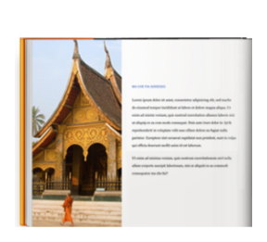**Blurb BookSmart®** is book making software. Loads of pre-designed and customizable layouts, a huge selection of fonts, and all the tools needed to make sophisticated books, [weekly planners](http://www.blurb.com/create/book/planners) and [notebooks](http://www.blurb.com/create/book/notebook). And now you can turn any book made with BookSmart into a beautiful ebook for the iPad®, iPhone®, or iPod touch®. Cost $0.00

<http://www.blurb.com/make/booksmart>

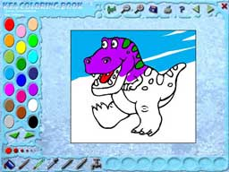

**Kea Coloring Book** lets you paint with a bucket fill or freestyle brush. There are over 300 coloring pages to download, and you can even create your own. Kea Coloring Book lets you paint with a bucket fill or freestyle brush. There are over 300 coloring pages to download, and you can even create your own. Cost: $ 0.00

<http://www.keasoftware.com/windows-software/kea-coloring-book-windows.html>



**Digital 3D Photos**- This program can create true 3D pictures and even make pseudo 3D images from your existing photos Cost: $0.00

<http://www.heuristicresearch.com/media/d3d.html>

**FunPhotor** is **fun** and easy to use **photo** blending software, a **fun**-filled Windows application that lets you blend your family portraits with well known artwork to create comical images. With a few short steps, you can add your **face** to the carved granite US Presidents on Mount Rushmore, put your portrait on a $100 bill, or create all sorts of gag gifts for your friends. Cost $0.00 for 7 day-trial or $50-70 for full versions.

<http://www.funphotor.com/buynow/buynow.htm>

**ZeallSoft Magic Mirror** is funny and easy to use photo distorting software. You can distorting your friend or family face and producing surreal effects! Have you ever heard the saying "laugh until you weep"? No! Don't worry, get Magic Mirror and try a face warp. It's an entertainment package. Whether yours is a group of friend or children, whether you opt for a face warp or warp picture, Magic Mirror will generate a laugh a minute. Magic Mirror is packed with laughter generating tools and all the features you will ever need to turn an ordinary image into something extraordinary. Just imagine, if you can, what the changes will be like when you apply the warp face or warp picture facility to someone you know or an image around you.

Cost $0.00 for 7 day-trial or $30-$50 for full versions.

[http://www.zeallsoft.com/buynow.htm#magicmirror](http://www.zeallsoft.com/buynow.htm%23magicmirror)

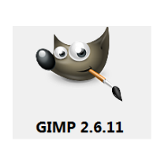GIMP is an acronym for GNU Image Manipulation Program. It is a freely distributed program for such tasks as photo retouching, image composition and image authoring . It has many capabilities. It can be used as a simple paint program, an expert quality photo retouching program, an online batch processing system, a mass production image renderer, an image format converter, etc. Cost $0.00

<http://www.gimp.org/>

[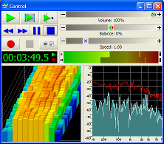](http://www.goldwave.com/features.php)

**GoldWave** is a highly rated, professional digital audio editor. It's fully loaded to do everything from the simplest recording and editing to the most sophisticated audio processing, restoration, enhancements, and conversions. Cost $0.00 for Trial or $49 for full version.

<http://www.goldwave.com/index.php>

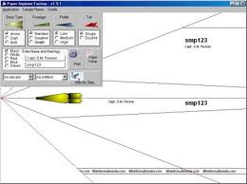

**Paper Airplane Factory**: This program allows students to use computer aided design to make and modify paper airplanes. They can print out their designs and build their planes using the provided instructions. Cost $0.00 for trial

<http://paper-airplane-factory.en.malavida.com/>

[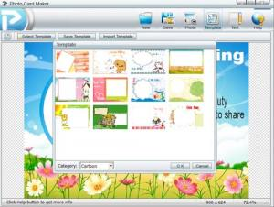](http://screenshots.en.sftcdn.net/en/scrn/70000/70097/photo-card-maker-2.jpg)

**Photo Card Maker**: Create personalized photo cards for New Year, Birthdays, Valentine's Day, Wedding, anniversaries or any occasions. Photo Card Maker comes with hundreds of card templates for you. You could just choose a template, personalize the messages and save to image file, that's all. Cost $ 0.00

<http://www.photo-card-maker.com/index.html>

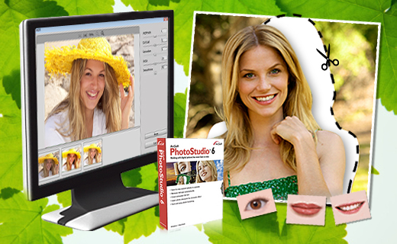

**PhotoStudio**  is powerful photo editing software featuring an array of advanced tools, filters and special effects inside a very friendly user interface. Beginners will appreciate the straight-forward design, while advanced users will love the performance and control. The program includes everything you need to manage, enhance, print, and get creative with your digital photos! Cost $0.00 for 15 day trial or $80.00 full version.

<http://www.arcsoft.com/photostudio/>

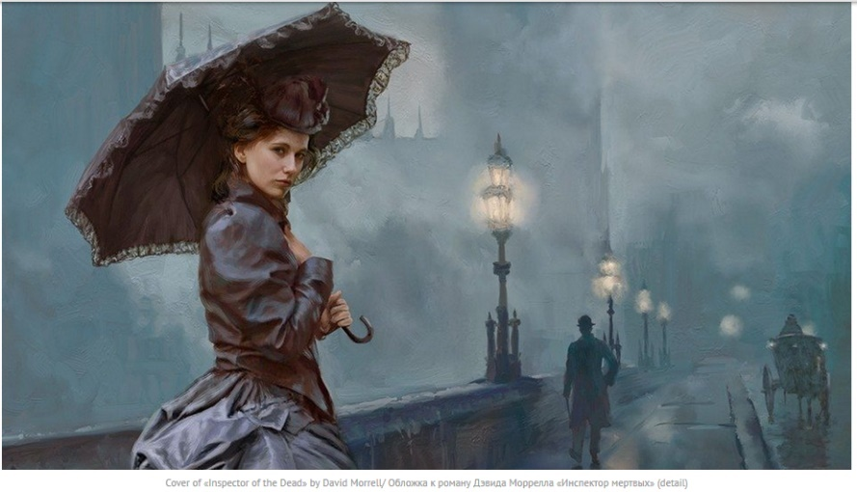

**ArtRage** is used for traditional style art, graphic design, picture book illustrations, movie and video game concept art, scientific illustrations, fan art, comics, caricatures, abstracts, photo editing, special effects, product design and more. Limited Trial Version $0.00 Full Version: $79.00

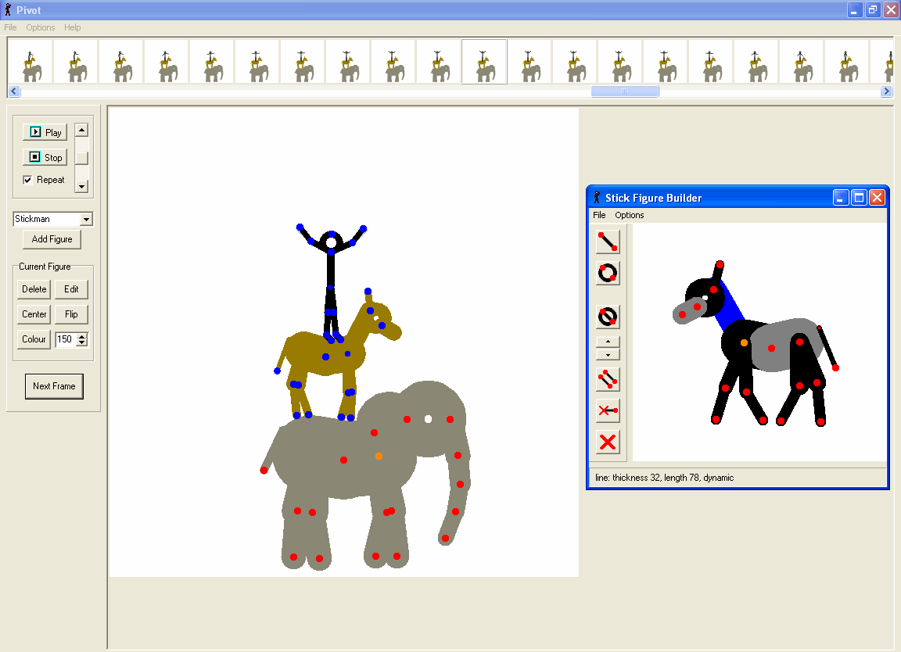

|  |  |
| --- | --- |
|  | **Pivot** makes it easy to create stick-figure animations. You can build your own stick figures and load your own backgrounds. The animations can be saved as animated gifs. Cost $0.00  <http://pivotanimator.net/> |

**Scratch**: A program to design your own games and interactive stories. Cost $0.00

<http://scratch.mit.edu/>

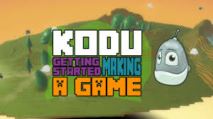

**Microsoft Kodu Game Lab** is a new visual programming language made specifically for creating games. It is designed to be accessible for children and enjoyable for anyone. The visual nature of the language allows for rapid design iteration using only an Xbox game controller for input (mouse/keyboard input is also supported). Kodu for the PC is available to download for free. Kodu for the XBox is also available in the USA on the XBox Marketplace, in the Indie Games channel for about $5.

 **Sculptris** is an elegant, powerful and yet easy to use 3D sculpting software, allowing the artist in you to simply focus on creating amazing 3D artwork. Gone are the technical and often tedious constraints typically associated with digital art. Cost $ 0.00

[http://www.pixologic.com/sculptris/#](http://www.pixologic.com/sculptris/%23)



**Meshmixer** is a free tool for making crazy 3D stuff without too much hassle.

Or silly stuff too. You decide. Cost: $0.00

<http://meshmixer.com/>



**Shape Collage:** Create picture collages in less than a minute with just a few mouse clicks Photos are automatically and intelligently placed using a very fast patent pending method Use photos on your computer or from the web to make collages. Make collages in any imaginable shape or form Rectangle, heart, circle, letters, or even draw your own shape! Cost $ 0.00

[**http://www.shapecollage.com/#utm_source=shapecollage&utm_medium=direct&utm_campaign=2.5.3&utm_nooverride=1&utm_content=home**](http://www.shapecollage.com/%23utm_source=shapecollage&utm_medium=direct&utm_campaign=2.5.3&utm_nooverride=1&utm_content=home)

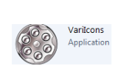 **VariIconsRevolve** is an Icon and Small graphics editor suite which allows you to create and modify icons with frames up to 256x256 size using 22 pixel and vector tools, effects and a variable gradient filling. now localized for English and German!

<http://sourceforge.net/projects/variicons/>

[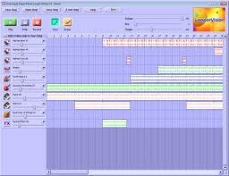](http://www.google.com/imgres?q=super+duper+music+looper&hl=en&safe=active&biw=720&bih=495&tbm=isch&tbnid=UHPqLafXC_YXfM:&imgrefurl=http://www.softpedia.com/progScreenshots/Super-Duper-Music-Looper-XPress-Screenshot-72892.html&docid=yec4kGJLCXabSM&imgurl=http://i1-win.softpedia-static.com/screenshots/Super-Duper-Music-Looper-XPress_1.png&w=1120&h=862&ei=osXtT9T6HYGC8QS9pJGHAg&zoom=1&iact=hc&vpx=272&vpy=143&dur=567&hovh=197&hovw=256&tx=95&ty=105&sig=104035654398378319798&page=1&tbnh=129&tbnw=168&start=0&ndsp=7&ved=1t:429,r:1,s:0,i:76)See how easy music-making can be. **Super Duper Music Looper** software is a fun, easy way for kids to learn the basics of music-making and recording. See how easy music-making can be. Super Duper Music Looper software is a fun, easy way for kids to learn the basics of music-making and recording.

Simulators

[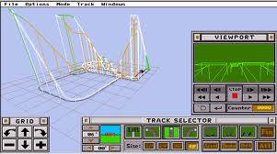](http://www.google.com/imgres?imgurl=http://www.jaygroh.com/rcwpics/makescr.gif&imgrefurl=http://www.jaygroh.com/rcsims.htm&h=357&w=640&sz=22&tbnid=6WDQr-4A2u0MIM:&tbnh=73&tbnw=130&prev=/search?q=disney+coaster+game&tbm=isch&tbo=u&zoom=1&q=disney+coaster+game&usg=__zjDbTscV3yQtNQ_c2yLjNHYr1is=&docid=0-MT7yJWAJ_jxM&hl=en&sa=X&ei=JuTsT9u5O8nw0gHp0tT_DQ&ved=0CGMQ9QEwBg&dur=41)

**Disney Coaster**: This program allows students to design and ride their own roller coaster while learning a little Physics in the process. Cost: No Longer sold.

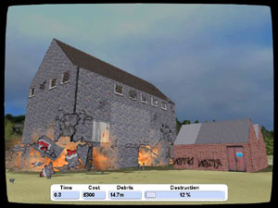

**Detonate:** This program simulates the destruction of a building by implosion. This technique is used in the demolition field. Cost: $0.00 for demo 5 Euros for full version.

<http://www.wildebeestgames.com/detonate.htm>

[](http://modelsimulator.com/photos/photo04.gif)

**The Flying-Model-Simulator** allows students to fly various model planes in a variety of conditions. Cost $0.00[http://modelsimulator.com/](http://modelsimulator.com/%20)

**[](http://www.google.com/imgres?q=nuclear+power+plant&num=10&hl=en&safe=active&biw=720&bih=495&tbm=isch&tbnid=y7iEVdAr8SZv4M:&imgrefurl=http://www.scientificamerican.com/article.cfm?id=coal-ash-is-more-radioactive-than-nuclear-waste&docid=vQSzHbkaN52BnM&imgurl=http://www.scientificamerican.com/media/inline/D41DB314-E7F2-99DF-3D6ACEC215A9A006_1.jpg&w=320&h=319&ei=UbrtT5iFMYX28wTzp5CBAg&zoom=1)Nuclear Reactor-:** This online web link simulates the running of a nuclear reactor

<http://esa21.kennesaw.edu/activities/nukeenergy/nuke.htm>

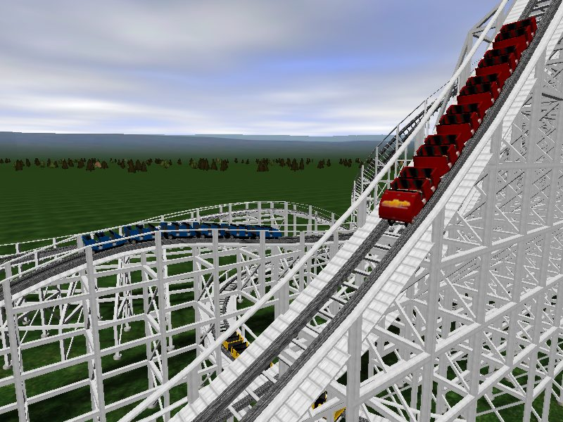

**NoLimits** is the ultimate roller coasters simulation game that lets you experience authentic roller coaster thrills. Focusing on realism and speed, NoLimits lets you ride real existing coasters, or build rollercoasters to your own specifications - with 27 different track styles, including inverted, hyper-coasters, wooden and shuttle coasters. Cost $0.00 for trial or $29.95 for full version.

<http://www.nolimitscoaster.com/index.html>

[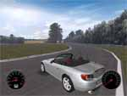](http://www.racer.nl/images/honda_lg.jpg)***Racer*** *is a free car simulator project (for non-commercial use), using high-end car physics to achieve a realistic feeling and an excellent render engine for graphical realism. Cars, tracks and such can be created relatively easy (compared to other, more closed driving simulations). The 3D files, physics and other Racer-specific file formats are documented. Editors and support programs are also available to get a very customizable and expandable simulator.*

[*http://www.racer.nl/*](http://www.racer.nl/)

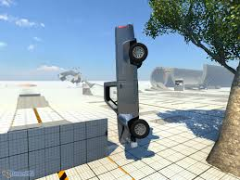**Beam NG Driver**: A car simulator which is designed to have realistic, accurate, destructible and malleable physics throughout the simulation. This simulator differs from other simulators in that it allows the players to jump ramps and go off road in the tech-demo version. The simulator also estimates the damage done to the car during these moves.

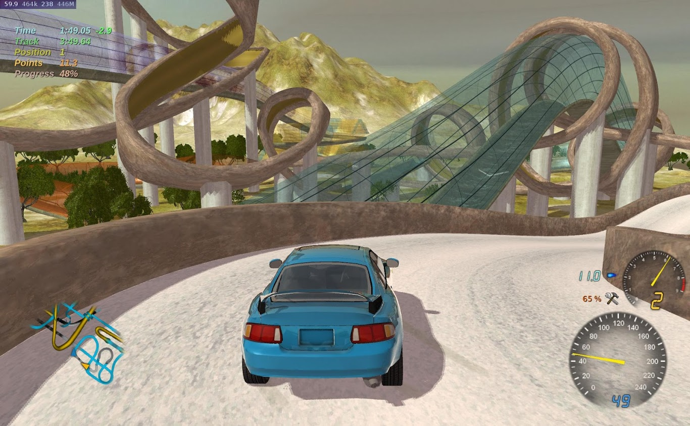

**Stunt Rally** is a racing game with rally style of driving, mostly on gravel. It features a rich variety of 172 [tracks](https://stuntrally.tuxfamily.org/tracks) in 34 sceneries also on other planets.Track difficulty ranges from short and easy to very difficult stunt tracks including jumps, skewed loops, pipes winding in 3D, obstacles or all at once.There are 20 [cars](https://stuntrally.tuxfamily.org/cars) to choose, 1 motorbike, 3 hovering spaceships and 1 bouncing sphere. The latter provide a fast and easier gameplay on flat tracks.

Game modes include:  
Single Race, Tutorials, Championships, Challenges, [Multiplayer](https://stuntrally.tuxfamily.org/wiki/doku.php?id=multiplayer) and Split Screen.  
Also Replays and Ghost drive are present.

The [Track Editor](https://stuntrally.tuxfamily.org/wiki/doku.php?id=editor) allows creating and modifying tracks. It uses a 3D spline generated road.

Cost: $0.00

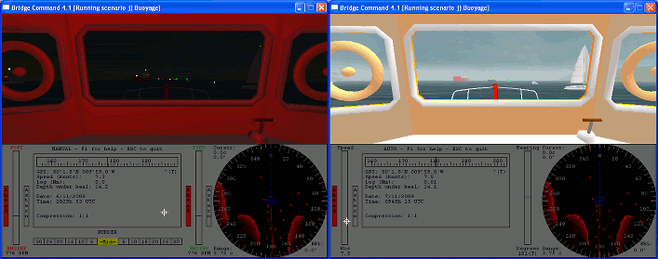

**Bridge Command** is very highly flexible, with the environmental model, ships, buoys, individual scenarios and almost all aspects of the simulation being configurable to your own needs. Bridge Command can be run on a single computer, with no additional devices needed. It can also be run with physical controls, and has an interface where a trainer can control scenarios in order to carry out training exercises, from a second computer. It can display on a single screen, or can display a full panoramic view across multiple screens using multiple computers. The radar picture is simulated in real-time, and includes standard marine radar controls such as gain and clutter, as well as features such as parallel indexes for blind pilotage and ARPA contact tracking.

<http://www.bridgecommand.co.uk/>

**[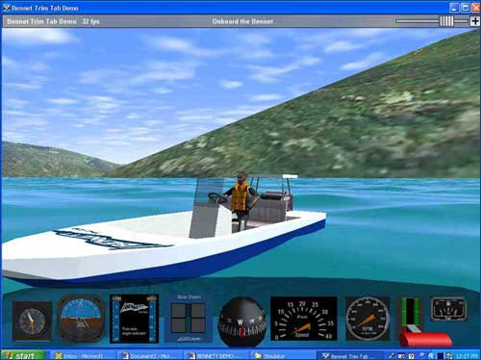](http://www.bennetttrimtabs.com/images/simulator_01big.jpg)Bennet Trim**

Take a ride in our virtual demo boat! You can also put the boat in different water and wave conditions. Cost: $0.00

<http://www.bennetttrimtabs.com/simulator.htm>

**[](http://www.google.com/imgres?q=sun&num=10&hl=en&safe=active&biw=720&bih=495&tbm=isch&tbnid=tpuEqUs5oIPYiM:&imgrefurl=http://science.nationalgeographic.com/science/photos/sun-gallery/&docid=cWSmkutmxBD5gM&imgurl=http://images.nationalgeographic.com/wpf/media-live/photos/000/065/cache/glowing-sun-prominence_6594_600x450.jpg&w=600&h=450&ei=yrbtT4qtJKXb0QHbk72LDg&zoom=1)Stellar Simulator**: This online web link simulates the life past and future of a star.

http://rainman.astro.illinois.edu/ddr/stellar/advanced.html

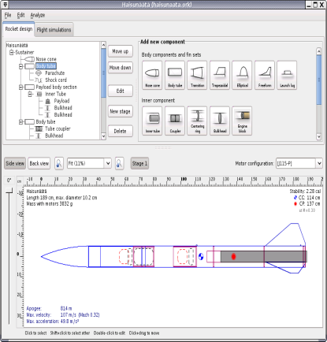

**OpenRocket** is a free, fully featured model rocket simulator that allows you to design and simulate your rockets before actually building and flying them. <http://openrocket.sourceforge.net/shots/main.png>

[](http://www.google.com/url?sa=i&rct=j&q=JHANABI&source=images&cd=&cad=rja&docid=6pei85lJ14YHqM&tbnid=RkM0C-PSaKT4PM:&ved=0CAUQjRw&url=http://www.sakura-hotel-hatagaya.com/blog/2010/07/14/index.php&ei=-CzUUd2kE4PQqwHTHw&bvm=bv.48705608,d.aWM&psig=AFQjCNH11HYsO3X2d1pqea82t_zk3WSEiQ&ust=1372946035096189)**JHANABI** This link takes you to a primitive fireworks simulator.

<http://www.albinoblacksheep.com/games/fireworks>

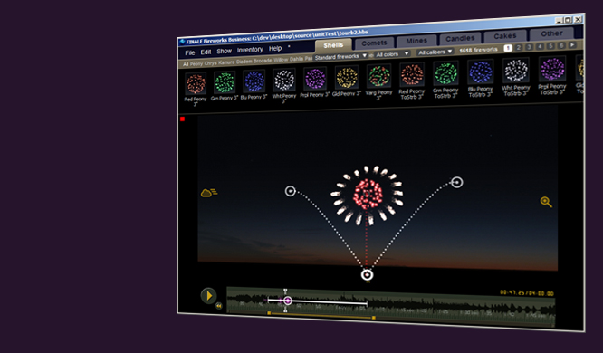**Finale Fireworks:** For fireworks professionals, our mission is to build you the software you've always dreamed of but never had...

Save time, shoot better shows, and have the peace of mind of knowing everything is under control.

Finale's **Visual Simulation** and **Inventory Management** software provide a complete system for running a pyrotechnics company. Free Trial Cost:$550-$1000

<http://www.finalefireworks.com/>

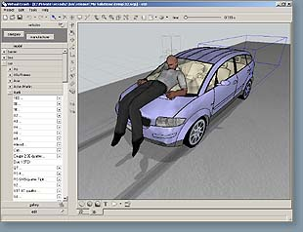

**VCrash** is a professional car crash simulator. Students can experiment with various type of car crashes.

<http://www.vcrash.com/>

[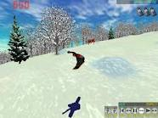](http://www.google.com/imgres?q=soulride+game&num=10&hl=en&safe=active&biw=720&bih=495&tbm=isch&tbnid=K4ynWdwji8_aOM:&imgrefurl=http://soulride.com/products/stratton.html&docid=xn5AO-WxUskwPM&imgurl=http://soulride.com/products/screenshots/images/strat02.jpg&w=640&h=480&ei=pcftT7KuEYjM9QTxipSQDQ&zoom=1)

**Soul Rider**- A virtual snowboarding program Free Demos available

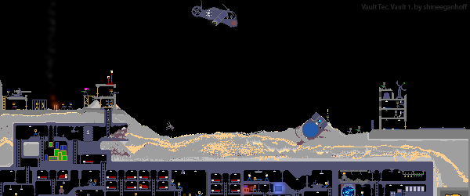

The Powder Toy is a free physics sandbox game, which simulates air pressure and velocity, heat, gravity and a countless number of interactions between different substances! The game provides you with various building materials, liquids, gases and electronic components which can be used to construct complex machines, guns, bombs, realistic terrains and almost anything else. You can then mine them and watch cool explosions, add intricate wirings, play with little stickmen or operate your machine. You can browse and play thousands of different saves made by the community or upload your own – we welcome your creations! Cost: $0.00

[**http://powdertoy.co.uk/**](http://powdertoy.co.uk/)

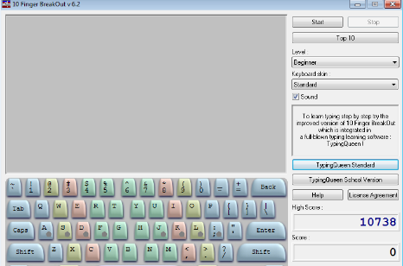Learning Games

**10 Finger Break Out**: A free arcade style game used to teach basic keyboard strokes. Cost: $0.00

<http://www.touch-typing-tutor.com/10FingerBreakOut-FreeTypingGame.htm>

Typing Invaders

Typing Invaders is a REAL arcade game, in which you are escaping from invaders, shooting and trying to hit invaders. This is no fake - you are playing space invaders ! (You are not just typing characters). With this free typing game you WILL have fun, but don't worry, by playing Typing Invaders you sure will be learning to type. Improve your typing skills with this free typing tutor - typing game ! License: Free

<http://www.touch-typing-tutor.com/>

|  |  |
| --- | --- |
| **Crayon Physics Deluxe**: is a 2D physics puzzle / sandbox game, in which you get to experience what it would be like if your drawings would be magically transformed into real physical objects. Solve puzzles with your artistic vision and creative use of physics. The game features awesome physics, 70 levels, and easy to use level editor. Cost $0.00 for Demo and $19.95 for the full copy.  <http://www.crayonphysics.com/index.html> |  |

This site offers games that help to develop math, strategy and logic skills. In a family, friendly environment. <http://www.coolmath-games.com/>



Funbrain, created for kids in grades Pre-K through 8, offers hundreds of free interactive games, books, videos, and printables that help kids develop skills in math, reading, problem-solving, and literacy.

<https://www.funbrain.com/>

Provides a wealth of educational video and games related to PBS shows. Provides a wide range of learning activities.

<http://pbskids.org/>

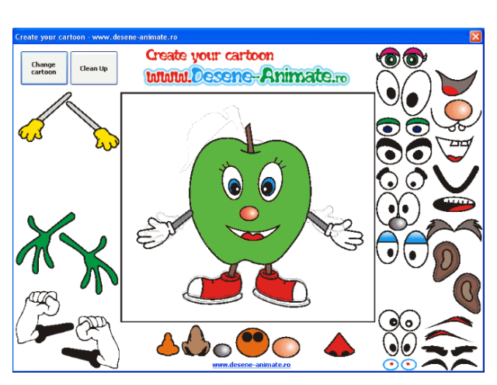**Desene-Animate**: A Mr. Potato head style program that allows kids to exercise their imagination creating various monsters from fruit.

<http://www.desene-animate.ro/jocuri-colorat.html>



**Jigsaw Puzzle Lite**, the most entertaining and easy-to-use free jigsaw puzzle game you've ever seen. Create your own puzzles from your favorite pics - with any number of pieces. Simple and handy puzzle-solving interface: expanding "side-boxes", "ghost image" behind the scene and "thumbnail" image. The program is free - it doesn't expire, doesn't contain any ads and includes a lot of free puzzles. Cost $0.00 Additional Puzzle Pack can be purchased for $9.95 each.

<http://www.kraisoft.com/puzzle-games/jigsaw/>

[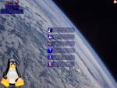](http://tux4kids.alioth.debian.org/tuxmath/screenshots/menu.jpg)TuxMath is an arcade game that helps kids practice their math facts. The main goal is to make it effective and fun! Cost $0.00

<http://tux4kids.alioth.debian.org/tuxmath/>

[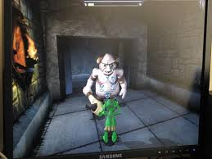](http://www.google.com/imgres?q=timez+attack&um=1&safe=active&hl=en&biw=1280&bih=927&tbm=isch&tbnid=k72vvPU2MLD4hM:&imgrefurl=http://littlemeninmylibrary.wordpress.com/2009/11/21/timez-attack-best-multiplication-computer-game-ever/&docid=s6-shqPhyyF26M&imgurl=http://farm3.static.flickr.com/2500/4122907417_64b7943e1b.jpg&w=500&h=375&ei=gi7UUb3ODMXGqwGttYBo&zoom=1&ved=1t:3588,r:21,s:0,i:150)Chase dangerous monsters, wind your way through dark tunnels - all while you learn your multiplication! [Timez Attack](http://www.bigbrainz.com/index.php?PARTNER=edufree) is a first person shooter game where you use math to fight your opponents instead of weapons! Home Edition is Free.

<http://www.bigbrainz.com>

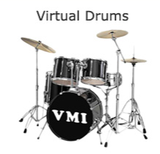**Virtual Musical Instruments**

Welcome to VirtualMusicalInstruments.com! We offer you the possibility of learning and creating music by playing [**Musical Instruments**](http://www.virtualmusicalinstruments.com/musical-instruments) online using your PC keyboard and mouse control as the interface. Our musical instruments include the [**virtual guitar**](http://www.virtualmusicalinstruments.com/guitar), [**virtual piano**](http://www.virtualmusicalinstruments.com/piano), [**virtual drums**](http://www.virtualmusicalinstruments.com/drums),[**virtual bongos**](http://www.virtualmusicalinstruments.com/bongos)and the [**virtual pan flute**](http://www.virtualmusicalinstruments.com/pan-flute).

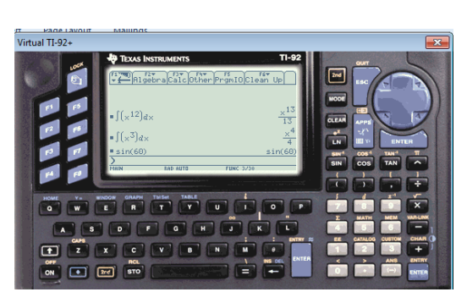Emulation

**Virtual TI-89/92(+) Emulator**: A program that allows the computer to behave as a TI graphing calculator. Cost: Program is free but user must have a TI calculator to set the program up.

<http://www.ticalc.org/pub/win/>

**MAME** stands for **M**ultiple **A**rcade **M**achine **E**mulator. When used in conjunction with images of the original arcade game's ROM and disk data, MAME attempts to reproduce that game as faithfully as possible on a more modern general-purpose computer. MAME can currently emulate several thousand different classic arcade video games from the late 1970s through the modern era. Cost $0.00 however user must supply ROMS.

<http://www.mameui.info/>

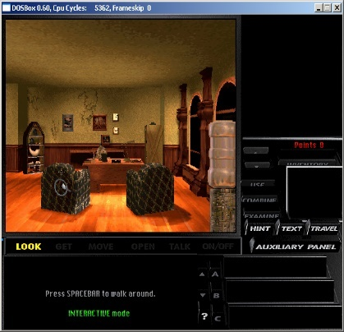

**DOSBox** also emulates CPU:286/386 realmode/protected mode, directory FileSystem/XMS/EMS,Tandy/Hercules/CGA/EGA/VGA/VESA graphics, a aSoundBlaster/Gravis Ultra Sound card for excellent sound compatibility with older games. Cost $0.00

<http://www.dosbox.com/information.php?page=0>

Entertainment



**Candy Land**: This classic board game has been converted to a computerized board game. Cost $ 9.99

[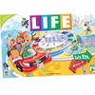](http://www.hasbrotoyshop.com/the-game-of-life?BR=578&ID=9617)<http://www.hasbro.com/?US>

**Life:** This classic board game has been converted to a computerized board game. . **This program can also be used to show the networking capabilities of computers.**

<http://www.hasbro.com/?US>

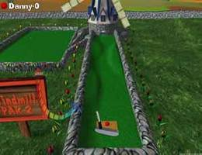

[**3-D Ultra Mini Golf**](http://www.agamesroom.com/game/3mg)**:** With Sierra's new 3D Ultra Mini Golf, you can immerse yourself in 18 holes of miniature golf action. Each new hole combines 3D graphics and clever play with actual physics, including calculated ball dynamics. **This program can also be used to show the networking capabilities of computers.** Cost: currently not being sold.



**Checkers** : This is a computerized version of a game that easily predates the computer.

Cost: $0.00

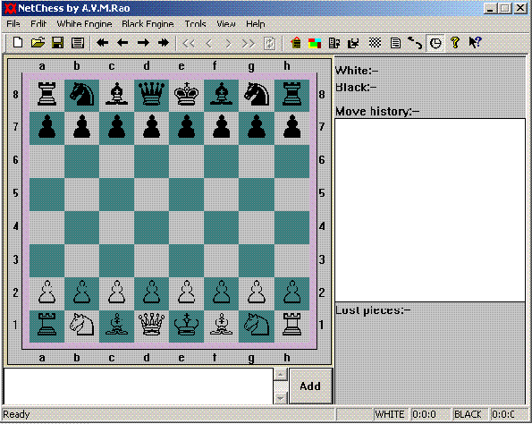**NetChess** is a chess program that allows you to play with opponent over internet/intranet or on the local computer. This software will verify your moves according to chess rules. Features include chess-clock, move logging, coordinate system, and much more. **This program can also be used to show the networking capabilities of computers.** Cost: $0.00

[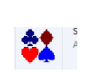http://www.freewaresoftwarelinks.com/software.php?id=26](http://www.freewaresoftwarelinks.com/software.php?id=26)

**Network Speed Card** is based on a host-client model. One player hosts the game and the second player then joins the game as a client. Obviously the host server must be ready before a client can join. This is a LAN game based on a classic card game. Cost $0.00



This is a virtual online fidget spinner. Using the fidget spinner is free. Beware that there is a link to Amazon to buy fidget spinners on the same page.

www.ffffidget.com

[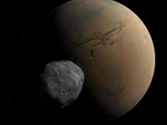](http://www.shatters.net/celestia/images/gallery/phobos-mars.jpg)**Tools**

**Celestia** is the free space simulation that lets you explore our universe in three dimensions. **Unlike most planetarium software,** Celestia doesn't confine you to the surface of the Earth. You can travel throughout the solar system, to any of over 100,000 stars, or even beyond the galaxy. Cost $ 0.00

<http://www.shatters.net/celestia/>

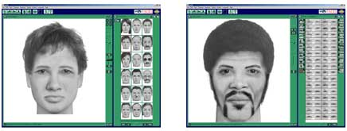**Faces 4.0** makes it easy for any police officer to create accurate composites with a click of a mouse. No forensic artist skills or experience are required. With FACES, composites can be created more quickly and inexpensively and used to solve crimes when a professional sketch artist isn’t available. FACES 4.0 can be used on any standard desktop or laptop computer running Microsoft Windows 98 or better. Cost $0.00 for demo Professional Versions $99-$600.

<http://www.iqbiometrix.com/products_faces_40.html>

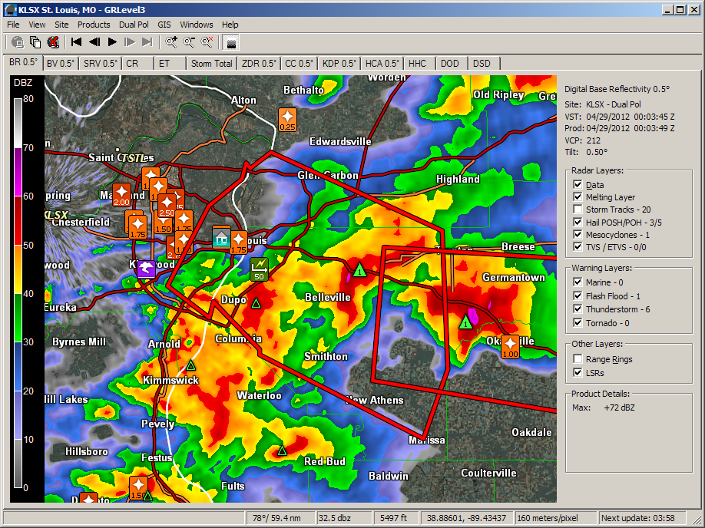**GRLevel3 Version 2** is a Windows viewer for live and archive NEXRAD Level III data. It displays high resolution base products, dual polarization products, and derived products along with Local Storm Reports and severe weather warnings. This program is used by storm chasers and others interested in severe weather phenomena. Cost: $0.00 for 21-day trial then$79.00

<http://www.grlevelx.com/>

|  |  |
| --- | --- |
| http://www.mirrorofbeauty.com/makeover3.jpg  **Mirror of Beauty**: A virtual make-over program. Cost $0.00 for trial or $19.95 Full Version <http://www.mirrorofbeauty.com/>    **MyChat** is a multi-clients chat program with nice graphical  layout. It allows future plug-in for game and utilities. MyChat implements the client authentication and data encryption to ensure the communication security. MyChat is able to work within LAN or over Internet. Cost $ 0.00 |  |

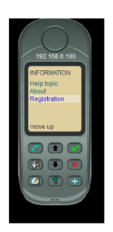

**Phone** is a small program that allows students to try voice over IP.

Stellarium Icon

**Stellarium** is a planetarium software that shows exactly what you see when you look up at the stars. It's easy to use, and free. www.stellarium.org/

**[](http://www.nch.com.au/verbose/vbsetup.exe)Verbose** is an easy and convenient text to speech converter that can read aloud or save spoken text to mp3 files. Reads any text on your computer out loud. Converts text to mp3. Cost: $30.00 Trial version available.

<http://www.nch.com.au/verbose/index.html>

**Balabolka** is a Text-To-Speech (TTS) program. All computer voices installed on your system are available to **Balabolka**. The on-screen text can be saved as a WAV, MP3, MP4, OGG or WMA file. The program can read the clipboard content, view the text from AZW, AZW3, CHM, DjVu, DOC, EPUB, FB2, HTML, LIT, MOBI, ODT, PRC, PDF and RTF files, customize font and background colour, control reading from the system tray or by the global hotkeys.

|  |  |  |
| --- | --- | --- |
| Balabolka |  | The program uses various versions of **Microsoft Speech API (SAPI)**; it allows to alter a voice's parameters, including rate and pitch. The user can apply a special substitution list to improve the quality of the voice's articulation. This feature is useful when you want to change the spelling of words. The rules for the pronunciation correction use the syntax of regular expressions. <http://www.cross-plus-a.com/balabolka.htm>  Cost $0.00 |