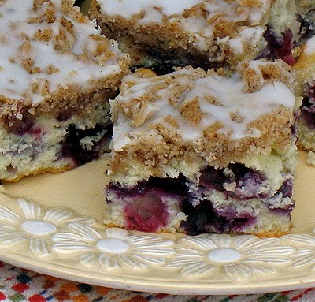
Blueberry Breakfast Cake
CAKE INGREDIENTS:
- 2 cups all-purpose flour
- 1/2 cup sugar
- 2 teaspoons baking powder
- 1 egg, lightly beaten
- 1/2 cup milk
- 1/4 cup butter or margarine, softened
- 1 teaspoon grated lemon peel
- 2 cups fresh or frozen blueberries

Topping
- 1/3 cup sugar
- 1/4 cup all-purpose flour
- 1/2 teaspoon ground cinnamon
- 4 tablespoons cold margarine

CAKE DIRECTIONS:

- Preheat oven to 350 degrees, grease a 9x9 inch baking pan.
- In a large bowl, whisk together the flour, sugar and baking powder.
- Add egg, milk, butter and lemon peel; mix just until dry ingredients are moistened.
- Fold in the blueberries.
- Spread into the greased 9-in. square baking pan.
- For topping, combine sugar, flour and cinnamon in a bowl using a pastry blender.
- Cut-in cold butter until mixture is crumbly. Sprinkle over batter in the pan.
- Bake for 35-40 minutes or until a toothpick comes out clean.

Note: If you are doing this at school, leave a cooling rack, label & potholders so the next class can take your cake out of the oven for you! Don’t forget to set your timer!

DAY 2:
- Preheat oven to 325 degrees. Put coffeecake on bottom rack for 10 minutes, or until warm throughout.
- For the drizzle, combine ½ cup powdered sugar and 2 tablespoons of milk.
- If too thick, add a few drops of additional milk at a time until it reaches drizzling consistency.
- Drizzle over the top of the warm cake and serve.

Recipe from Annie’s Recipes

