Quality Scones and Biscuits

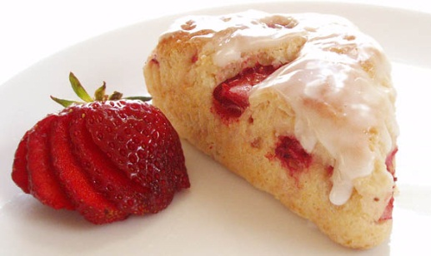
Appearance- same size, flat tops, straight sides
Color- golden brown
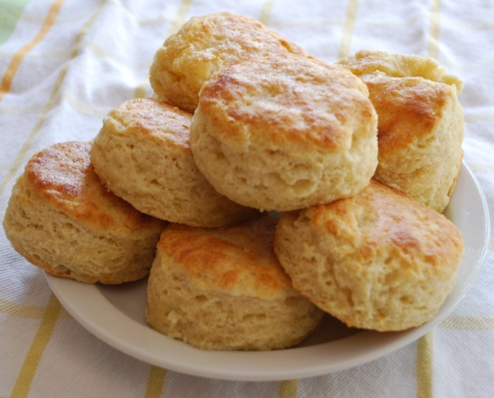
Texture- light, tender, flaky
Flavor- delicate
Test for doneness- golden brown, dry tops

