Apple Pie Salsa with Cinnamon Sugar Tortilla Chips

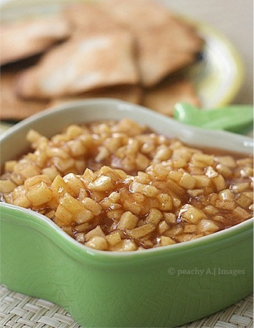
Salsa Ingredients:
- 1 tsp. cornstarch
- 1 tsp. water
- 2 apples, peeled, cored & diced
- 2 tbsp. lemon juice
- 3 tbsp. brown sugar
- ¼ tsp. cinnamon

Salsa Directions:
- Mix together water and cornstarch in a small bowl until dissolved. Set aside.
- Combine the apples, lemon juice, brown sugar and cinnamon in a small sauce pan.
- Cook the apple mixture until it is boiling to extract the juices from the apples.
- Add in the cornstarch-water mixture and stir until the sauce has thickened into a sauce.
- Serve in a small bowl.
Cinnamon Sugar Tortilla Chips:
5 (6-inch) wheat tortillas
2 tablespoons butter, melted
1/2 teaspoon cinnamon
1 1/2 tablespoons sugar

Directions:
- Preheat oven to 400 degrees, spray two cookie sheets with baking spray.
- Mix together cinnamon & sugar in a small bowl, set aside.
- Using a sharp knife or pizza cutter, cut the tortillas into triangles pieces.
- Arrange tortilla triangles in a single layer on the baking sheets.
- Brush the tortillas with butter, sprinkle with cinnamon and sugar mixture
- Bake for 5-7 minutes (until crisp and edges start to curl). Watch the chip carefully, as they can burn easily!
- Once the chips are done, remove them from the oven to cool. Chips will continue to crisp as they cool. Serve with the Apple Pie Dip.

Apple Pie Salsa with Cinnamon Sugar Tortilla Chips

Salsa Ingredients:
- 1 tsp. cornstarch
- 1 tsp. water
- 2 apples, peeled, cored & diced
- 2 tbsp. lemon juice
- 3 tbsp. brown sugar
- ¼ tsp. cinnamon

Salsa Directions:
- Mix together water and cornstarch in a small bowl until dissolved. Set aside.
- Combine the apples, lemon juice, brown sugar and cinnamon in a small sauce pan.
- Cook the apple mixture until it is boiling to extract the juices from the apples.
- Add in the cornstarch-water mixture and stir until the sauce has thickened into a sauce.
- Serve in a small bowl.

Cinnamon Sugar Tortilla Chips:
5 (6-inch) wheat tortillas
2 tablespoons butter, melted
1/2 teaspoon cinnamon
1 1/2 tablespoons sugar

Directions:
- Preheat oven to 400 degrees, spray two cookie sheets with baking spray.
- Mix together cinnamon & sugar in a small bowl, set aside.
- Using a sharp knife or pizza cutter, cut the tortillas into triangles pieces.
- Arrange tortilla triangles in a single layer on the baking sheets.
- Brush the tortillas with butter, sprinkle with cinnamon and sugar mixture
- Bake for 5-7 minutes (until crisp and edges start to curl). Watch the chip carefully, as they can burn easily!
- Once the chips are done, remove them from the oven to cool. Chips will continue to crisp as they cool. Serve with the Apple Pie Dip.

