Ions Examination
_____________________________________________________________________________________

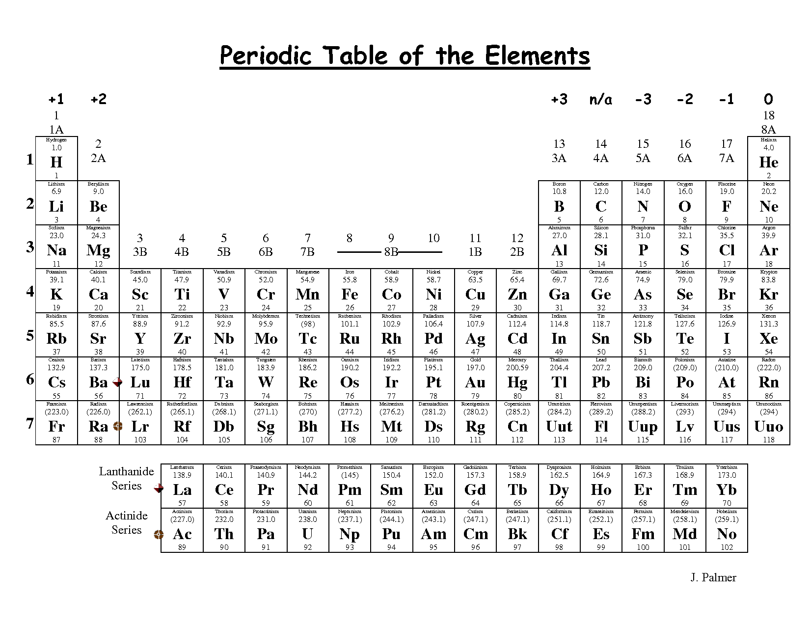
** YOU SHOULD KNOW ALL IONS THAT CORRESPOND TO THE PERIODIC TABLE**

Cations:

Cations
Ammonium: NH₄⁺¹
Hydronium: H₃O⁺¹ (not on ion sheet)

Anions: -1
Nitrite: NO₂⁻¹
Nitrate: NO₃⁻¹
Acetate: C₂H₃O₂⁻¹
Hydroxide: OH⁻¹
Hypochlorite: ClO⁻¹
Chlorite: ClO₂⁻¹
Chlorate: ClO₃⁻¹
Perchlorate: ClO₄⁻¹

Anions -2
Sulfate: SO₄⁻²
Sulfite: SO₃⁻²
Carbonate: CO₃⁻²

Anions -3
Phosphate: PO₄⁻³
Phosphite: PO₃⁻³

