Fidgets
Fidgets can be a helpful tool to help children attend in the classroom. Many times children need to keep their hands busy, just as adults often do. Have you ever found yourself fidgeting/fiddling with a pen cap, a rubber band, or a paper clip? Sometimes we find ourselves fidgeting with items unconsciously, but in actuality, the fidgeting is helping us self-regulate. Some tools that have proven to be beneficial in the classroom include items such as koosh balls, coil bracelets, and putty. Initially, your child may find these items to be distracting. If your child continues to be distracted by a fidget after using it for several days, it is not a useful tool, and other strategies to increase attention/concentration should be attempted.
Fidgets can be found at local stores such as Wal-Mart, The Dollar Tree, or Target. If you would prefer to order fidgets, a link for Office Playground is provided below. The ogosoft stress ball is a good choice for children that toss/drop fidgets often. Using a clip/carabiner it can be attached to a belt loop or bracelet. Stress balls are wonderful fidgets, but when dropped they can roll quite far! Using stress toys in various shapes such as the star shown below will not roll as far.
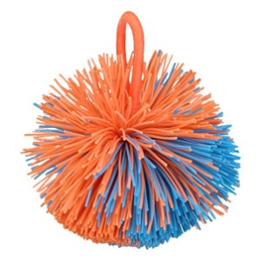
www.officeplayground.com

OgoSoft Stress Ball Bendeez Star Stress Toy

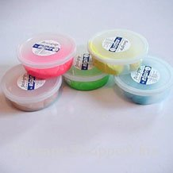
Therapy putty is a wonderful tool for keeping hands busy. Green (medium resistance) is typically used in the classroom.

http://www.therapyshoppe.com/therapy/index.php?main_page=index&cPath=6&products_id=1876&sort=20a&page=1

