Pencil Grips
If your child is not demonstrating and efficient pencil grasp, providing them with a pencil gripper can be very helpful. A variety of grippers are available in stores (The Learning Shop), as well as online. Several types of grips are available. It may be beneficial to try various grippers to see which works best for your child. Listed below are three types of grips that work well.

The Grotto Grip
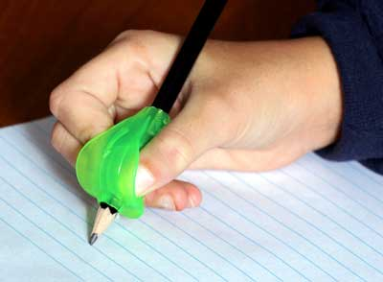

https://pathwaysforlearning.com/Products_-_Grotto_Grip.html

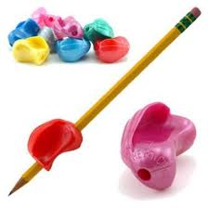
The Crossover Grip

Available at The Learning Shop
http://www.thewritingpenstore.com/p-1002-the-crossover-pencil-grip-neon.aspx?gclid=CLWqkMCzo68CFe4DQAod8g0fXQ

The Grip Pencil Grip
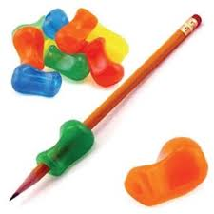

Available at The Learning Shop
http://thepencilgrip.com/dyn_prod.php?p=TPITPG-001&k=27468&gclid=CPj6-aK1o68CFWUQNAodCHfaXg

