Balanced Literacy Learning
September 11-15, 2017
7th and 8th Grade

Common Core Standards Addressed:
- CCSS.ELA-Literacy.RI.8.2
Determine a central idea of a text and analyze its development over the course of the text, including its relationship to supporting ideas; provide an objective summary of the text.
- CCSS.ELA-Literacy.RI.8.3
Analyze how a text makes connections among and distinctions between individuals, ideas, or events (e.g., through comparisons, analogies, or categories).
- CCSS.ELA-Literacy.W.8.10
Write routinely over extended time frames (time for research, reflection, and revision) and shorter time frames (a single sitting or a day or two) for a range of discipline-specific tasks, purposes, and audiences.
- CCSS.ELA-Literacy.L.8.2.c
Spell correctly.
- CCSS.ELA-Literacy.L.8.5.b
Use the relationship between particular words to better understand each of the words.
Learning Targets
Students will:
- Review Habits 1-5 in The 7 Habits of Highly Effective Teens (Read)
- Understand the first two laws of leadership according to How to Step Up (Read)
- Respond to 3 journal entries to develop writing endurance (Write)
- Identify helping and linking verbs in a sentence (POS)
- Seek synonyms for commonly over-used words (Vocab)
- Speak with limited verbal pauses during an impromptu speech (Speak)
Anticipated Weekly Outlook:
Monday 9/11  Circle Up  - Share synonyms for love and hate, and add good and bad  - Draw POS graphic  - Intro How to Step Up  Sm. Group/Work Time  - Meet with Mrs. K for Habit 1 Review  - Read p. 1-11 with partner  - Other weekly tasks  Wrap Up  - Spelling Pretest | Tuesday 9/12  Circle Up  - Share synonyms for good and bad, and add sad and happy  - Discuss Step Up  - Helping verbs song  Sm. Group/Work Time  - Meet with Mrs. K for Habit 2 Review  - Read Law #1 in Step Up with partner  - Other weekly tasks  Wrap Up  - Spelling Pretest | Wednesday 9/13  Early Release  Circle Up  - Impromptu 30 second speeches with limited verbal pauses | Thursday 9/14  Circle Up  - Share synonyms for sad and happy, and add fun and boring  - Discuss Step Up  - Helping verbs song  Sm. Group/Work Time  - Meet with Mrs. K for Habit 3 Review  - Read Law #2 in Step Up with partner  - Other weekly tasks  Wrap Up  - Spelling Pretest | Friday 9/15  Circle Up  - Share synonyms for fun and boring, and add cool and lame  - Discuss Step Up  - Helping verbs song  Sm. Group/Work Time  - Meet with Mrs. K for Habit 4 Review  - Other weekly tasks  Wrap Up  - Spelling Pretest
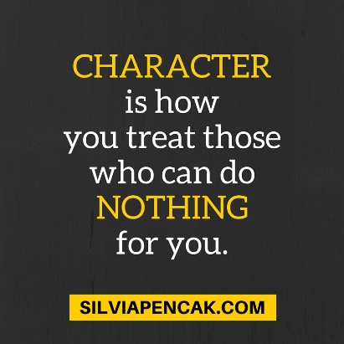
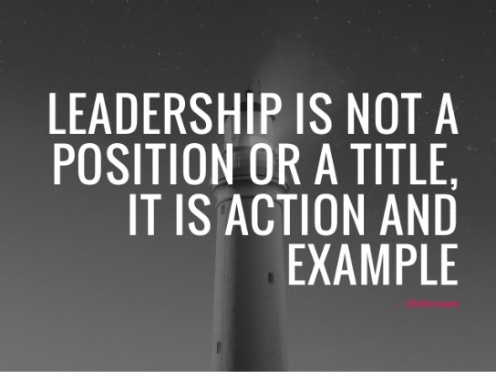

Additional Weekly Tasks:
These are to be worked on during small group time, after completing assigned reading
- Choose 3 of the 6 journal entries
Entries need to be dated, titled, and should be a minimum of 10 sentences.
- What paradigms do you have about yourself? Do they help or hinder you?
- Share about a time when you had a paradigm shift about someone else.
- What matters most to you? What are the principles you live by?
- What are some things you do that you are proud of?
- What talent would you like to develop more?
- Free choice
- Practice writing down the helping verbs
- Visit the library

