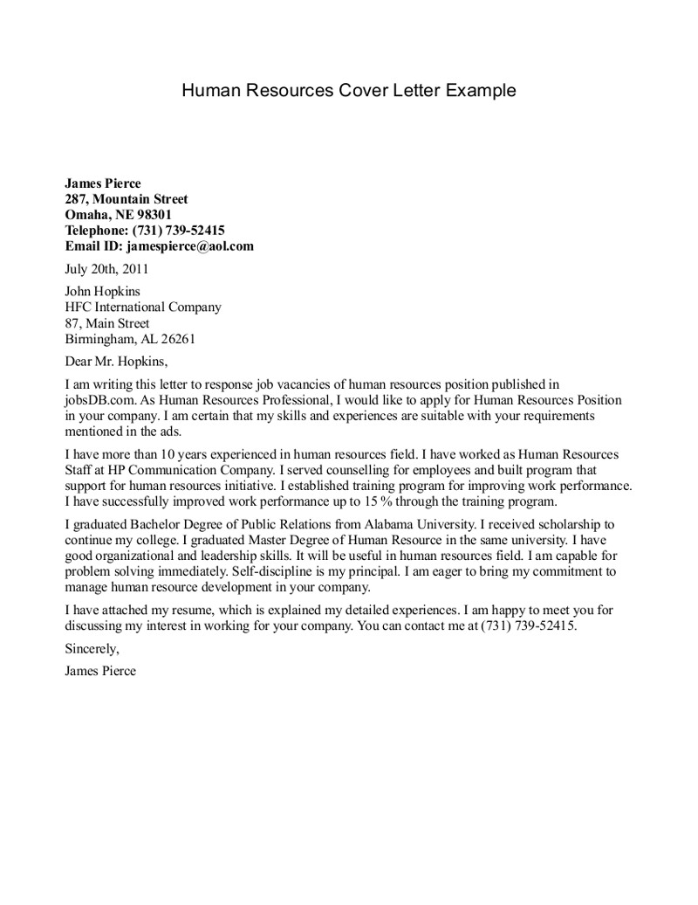

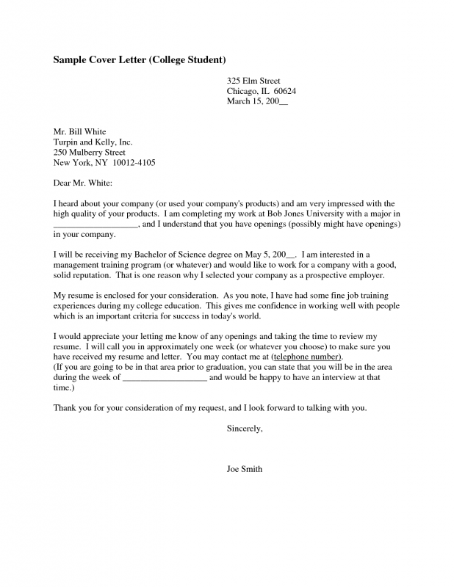

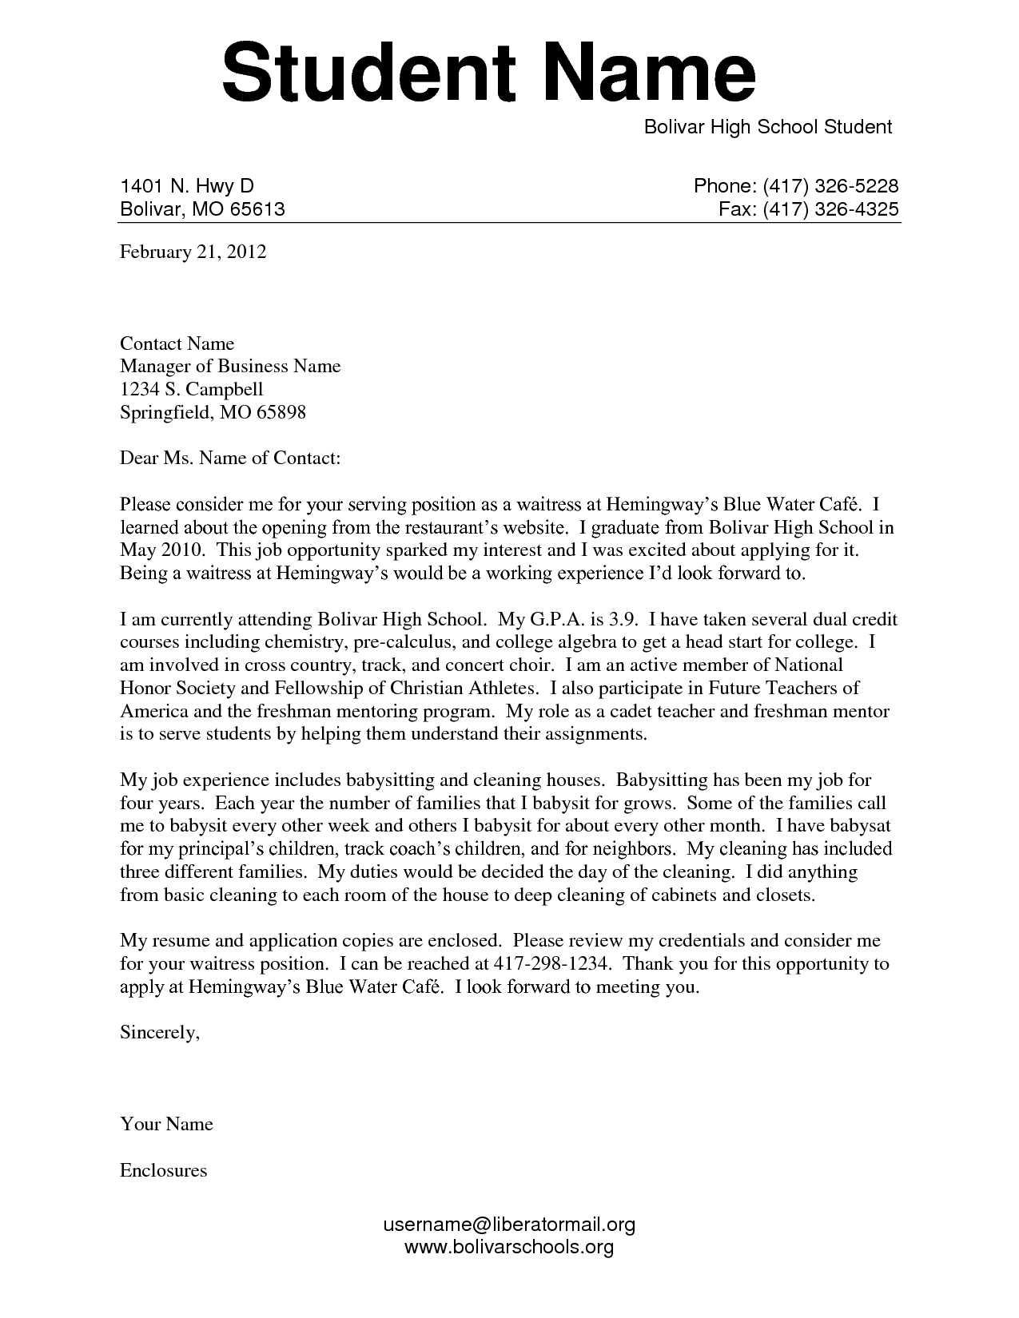

[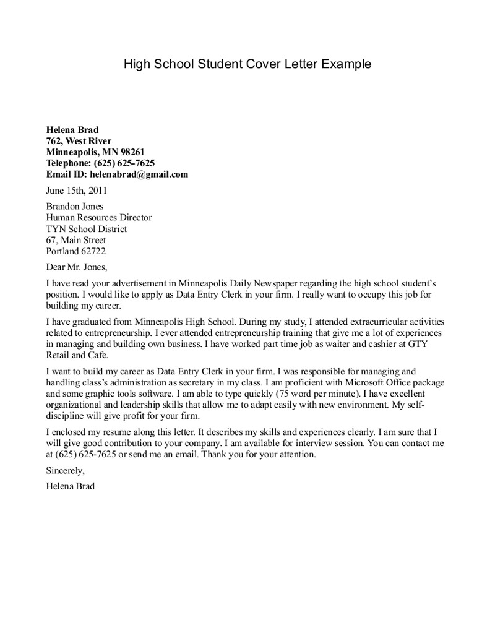](https://www.google.com/url?sa=i&rct=j&q=&esrc=s&source=images&cd=&cad=rja&uact=8&ved=0ahUKEwie94HDhcnYAhVEOiYKHd4yCMcQjRwIBw&url=https://www.pinterest.com/pin/515169644859815773/&psig=AOvVaw210SLG491B9774I2p1uyPM&ust=1515524130205881)

[](http://www.google.com/url?sa=i&rct=j&q=&esrc=s&source=images&cd=&cad=rja&uact=8&ved=0ahUKEwi41vDmhcnYAhWBNSYKHV7HC9QQjRwIBw&url=http://www.guamreview.com/sample-cover-letters-for-high-school-students/awesome-sample-cover-letters-for-high-school-students-67-on-job-hunting-cover-letter-sample-with-sample-cover-letters-for-high-school-students/&psig=AOvVaw210SLG491B9774I2p1uyPM&ust=1515524130205881)