[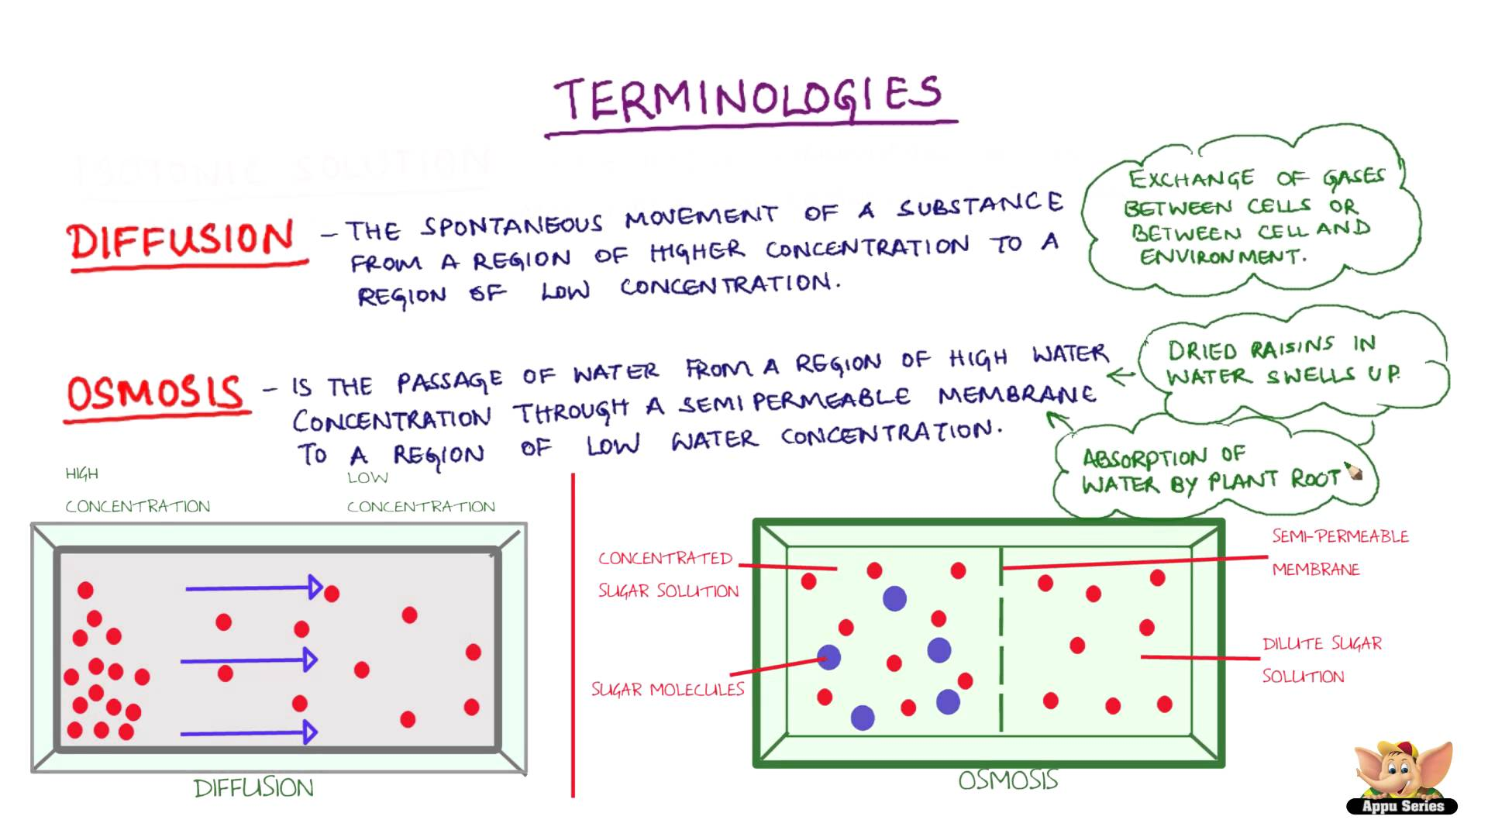](http://www.google.com/url?sa=i&rct=j&q=&esrc=s&source=images&cd=&cad=rja&uact=8&ved=0CAcQjRxqFQoTCIX_qN674MgCFYRYJgod7HYIxQ&url=http://www.youtube.com/watch?v%3DcVAlNfR4yv4&psig=AFQjCNHUvauSbL2yWDx5TOqKgDgA6JUP6w&ust=1445960116277132)