Plant Adaptations information from Missouri Botanical Gardens
The Desert
The desert is very dry and often hot. Annual rainfall averages less than 10 inches per year, and that rain often comes all at the same time. The rest of the year is very dry. There is a lot of direct sunlight shining on the plants. The soil is often sandy or rocky and unable to hold much water. Winds are often strong, and dry out plants. Plants are exposed to extreme temperatures and drought conditions. Plants must cope with extensive water loss.
Desert Plant Adaptations
- Some plants, called succulents, store water in their stems or leaves;
- Some plants have no leaves or small seasonal leaves that only grow after it rains. The lack of leaves helps reduce water loss during photosynthesis. Leafless plants conduct photosynthesis in their green stems.
- Long root systems spread out wide or go deep into the ground to absorb water;
- Some plants have a short life cycle, germinating in response to rain, growing, flowering, and dying within one year. These plants can evade drought.
- Leaves with hair help shade the plant, reducing water loss. Other plants have leaves that turn throughout the day to expose a minimum surface area to the heat.
- Spines to discourage animals from eating plants for water;
- Waxy coating on stems and leaves help reduce water loss.
- Flowers that open at night lure pollinators who are more likely to be active during the cooler night.
- Slower growing requires less energy. The plants don't have to make as much food and therefore do not lose as much water.
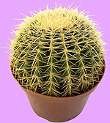 | 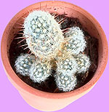 | 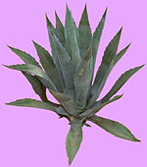
This cactus displays several desert adaptations: it has spines rather than leaves and it stores water in its stem. | This cactus displays light-colored hair that helps shade the plant. | This plant has a waxy coating on its leaves.

The Temperate Grasslands
The temperate grasslands, also called prairie, feature hot summers and cold winters. Rainfall is uncertain and drought is common. The temperate grasslands usually receive about 10 to 30 inches of precipitation per year. The soil is extremely rich in organic material due to the fact that the above-ground portions of grasses die off annually, enriching the soil. The area is well-suited to agriculture, and few original prairies survive today.
- During a fire, while above-ground portions of grasses may perish, the root portions survive to sprout again
- Some prairie trees have thick bark to resist fire
- Prairie shrubs readily resprout after fire
- Roots of prairie grasses extend deep into the ground to absorb as much moisture as they can
- Extensive root systems prevent grazing animals from pulling roots out of the ground
- Prairie grasses have narrow leaves which lose less water than broad leaves
- Grasses grow from near their base, not from tip, thus are not permanently damaged from grazing animals or fire
- Many grasses take advantage of exposed, windy conditions and are wind pollinated
- Soft stems enable prairie grasses to bend in the wind

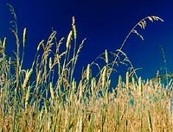 | 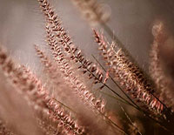
Soft stems enable prairie grasses to bend in the wind. Narrow leaves minimize water loss. | Many grasses are wind pollinated and are well-suited to the exposed, windy conditions of the grasslands.
The Tropical Rainforest

The tropical rainforest is hot and it rains a lot, about 80 to 180 inches per year. This abundance of water can cause problems such as promoting the growth of bacteria and fungi which could be harmful to plants. Heavy rainfall also increases the risk of flooding, soil erosion, and rapid leaching of nutrients from the soil (leaching occurs when the minerals and organic nutrients of the soil are "washed" out of the soil by rainfall as the water soaks into the ground). Plants grow rapidly and quickly use up any organic material left from decomposing plants and animals. This results is a soil that is poor. The tropical rainforest is very thick, and not much sunlight is able to penetrate to the forest floor. However, the plants at the top of the rainforest in the canopy, must be able to survive 12 hours of intense sunlight every day of the year. There is a great amount of diversity in plant species in the tropical rainforest.
- drip tips and waxy surfaces allow water to run off, to discourage growth of bacteria and fungi
- buttresses and prop and stilt roots help hold up plants in the shallow soil
- some plants climb on others to reach the sunlight
- some plants grow on other plants to reach the sunlight
- flowers on the forest floor are designed to lure animal pollinators since there is relatively no wind on the forest floor to aid in pollination
- smooth bark and smooth or waxy flowers speed the run off of water
- plants have shallow roots to help capture nutrients from the top level of soil.
- many bromeliads are epiphytes (plants that live on other plants); instead of collecting water with roots they collect rainwater into a central reservoir from which they absorb the water through hairs on their leaves
- epiphytic orchids have aerial roots that cling to the host plant, absorb minerals, and absorb water from the atmosphere

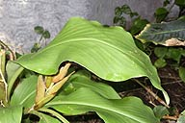 | 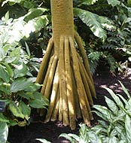 | 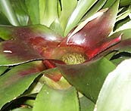
Drip-tips on leaves help shed excess water. | Prop roots help support plants in the shallow soil. | Some plants collect rainwater into a central reservoir.
The Temperate Rain Forest

The temperate rain forest features minimal seasonal fluctuation of temperature: the winters are mild and the summers cool. The temperate rain forest receives a lot of precipitation, about 80 to 152 inches per year. Condensation from coastal fogs also add to the dampness. The soil is poor in nutrients. Large evergreen trees, some reaching 300 feet in height, are the dominant plant species
- epiphytes such as mosses and ferns grow atop other plants to reach light.
- cool temperatures lead to slow decomposition but seedlings grow on "nurse logs" to take advantage of the nutrients from the decomposing fallen logs.
- trees can grow very tall due to amount of precipitation.

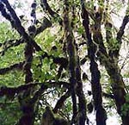 | 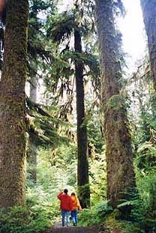
Epiphytes live on other plants to reach the sunlight. | Trees can grow very tall in this very moist environment.

The Temperate Deciduous Forest
There are four distinct seasons in the temperate deciduous forest: spring, summer, autumn, and winter. The temperature varies from hot in the summer to below freezing in the winter. Rain is plentiful, about 30 to 50 inches per year. The temperate deciduous forest is made up of layers of plants; the number of layers depends upon factors such as climate, soil, and the age of the forest. The tallest trees make up the forest canopy which can be 100 feet or more above the ground. Beneath the canopy, the understory contains smaller trees and young trees. These understory trees are more shade tolerant than canopy trees. Below the understory is a shrub layer. Carpeting the forest floor is the herb layer made up of wildflowers, mosses, and ferns. Fallen leaves, twigs, and dried plants cover the ground, decompose, and help add nutrients to the topsoil.
- wildflowers grow on forest floor early in the spring before trees leaf-out and shade the forest floor
- many trees are deciduous (they drop their leaves in the autumn, and grow new ones in spring). Most deciduous trees have thin, broad, light-weight leaves that can capture a lot of sunlight to make a lot of food for the tree in warm weather; when the weather gets cooler, the broad leaves cause too much water loss and can be weighed down by too much snow, so the tree drops its leaves. New ones will grow in the spring.
- trees have thick bark to protect against cold winters

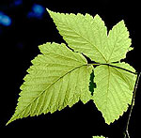 | 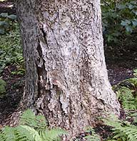 | 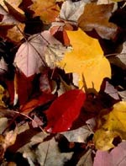
Broad leaves can capture a lot of sunlight for a tree. | Many trees have thick bark to protect against the cold winters in the temperate deciduous forest. | In the autumn, deciduous trees drop their leaves to minimize water loss.

The Taiga
Also known as boreal forests, the taiga is dominated by conifers (cone-bearing plants), most of which are evergreen (bear leaves throughout the year). The taiga has cold winters and warm summers. Some parts of the taiga have a permanently frozen sub-layer of soil called permafrost. Drainage is poor due to the permafrost or due to layers of rock just below the soil surface, and together with the ground carved out by receding glaciers, lead to the development of lakes, swamps, and bogs. The taiga receives about 20 inches of precipitation per year. The soil is acidic and mineral-poor. It is covered by a deep layer of partially-decomposed conifer needles.
Taiga Plant Adaptations
- many trees are evergreen so that plants can photosynthesize right away when temperatures rise
- many trees have needle-like leaves which shape loses less water and sheds snow more easily than broad leaves
- waxy coating on needles prevent evaporation
- needles are dark in color allowing more solar heat to be absorbed
- many trees have branches that droop downward to help shed excess snow to keep the branches from breaking

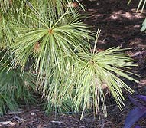 | 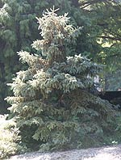
Needle-like leaves help reduce water loss and aids in the shedding of snow. | The shape of many conifer trees helps shed heavy snow to save branches from breaking.
Tundra

The tundra is cold year-round—it has short cool summers and long, severe winters. The tundra has a permanently frozen sublayer of soil called permafrost. Drainage is poor due to the permafrost and because of the cold, evaporation is slow. The tundra receives little precipitation, about 4 to 10 inches per year, and what it does receive is usually in the form of snow or ice. It has long days during the growing season, sometimes with 24 hours of daylight, and long nights during the winter. There is little diversity of species. Plant life is dominated by mosses, grasses, and sedges.
Tundra Plant Adaptations
- Tundra plants are small (usually less than 12 inches tall) and low-growing due to lack of nutrients, because being close to the ground helps keep the plants from freezing, and because the roots cannot penetrate the permafrost.
- Plants are dark in color—some are even red—this helps them absorb solar heat.
- Some plants are covered with hair which helps keep them warm.
- Some plants grow in clumps to protect one another from the wind and cold.
- Some plants have dish-like flowers that follow the sun, focusing more solar heat on the center of the flower, helping the plant stay warm.

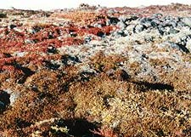 | 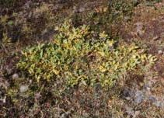
These tundra plants are low-growing. | This plant grows in a clump to help conserve heat.

Plant Adaptations in Water

Plant Adaptations in Water
- underwater leaves and stems are flexible to move with water currents
- some plants have air spaces in their stems to help hold the plant up in the water
- submerged plants lack strong water transport system (in stems); instead water, nutrients, and dissolved gases are absorbed through the leaves directly from the water.
- roots and root hairs reduced or absent; roots only needed for anchorage, not for absorption of nutrients and water
- some plants have leaves that float atop the water, exposing themselves to the sunlight
- in floating plants chlorophyll is restricted to upper surface of leaves (part that the sunlight will hit) and the upper surface is waxy to repel water
- Some plants produce seeds that can float

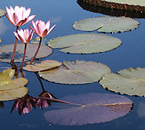 | 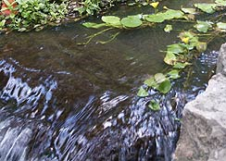
In floating plants, chlorophyll is restricted to the upper surface. Note the green color on the top of the leaves and the reddish underside of the overturned leaf. | Aquatic plants must be flexible to withstand the pressures of moving water.

