STEMS

Function
- Framework for leaves, flowers and seeds
- Continuation of vascular system carrying water and minerals from the soil,
and sugars manufactured in leaves throughout the plant.
- Green stems also manufacture food (photosynthesis).
- Food storage

Uses
- Aesthetic (winter interest in the landscape, appealing bark, etc.)
- Feed and food
- Fuel
- Plant identification
- Propagation (cuttings and layering) = Reproduction
- Wildlife habitat
- Wood industry and construction

Common Types of Stems

- Shoot – First year growth on a woody or herbaceous plant.
- Twig – Woody stem less than one year old.
- Branch – Woody stem more than one year old.
- Trunk – Main support stem(s) of woody plants.
- Water sprouts – Juvenile adventitious shoots arising on a branch. Generally very rapid, upright-growth, and poorly attached to the main limb.
- Suckers – Juvenile adventitious shoots arising from the roots, generally rapid, upright-growing.
- Canes – Stems with relatively large pith and usually living for only one to two years. (roses, grapes, blackberries, and raspberries)

Herbaceous Stems Woody Stems
- Green stems manufacture - Usually brown (not green)
food (photosynthesis)

- Flexible stems - Stronger / more rigid (wood)

- Not good at storing food - Good at storing food

* Both Carry Water and Nutrients (xylem ↑ and phloem ↓)

* Both connect the roots to the leaves.

Modified Stems
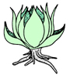
Bulb – Thickened, underground stem with fleshy storage leaves attached at base. (tulips, lilies, onions)
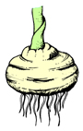

Corm – Short, thickened, underground stem with reduced scaly leaves (gladiolus)
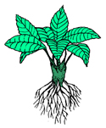

Crown – Compressed stem having leaves and
flowers growing above and roots beneath (strawberry plant, dandelion, African violet)

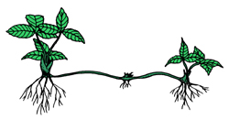

Stolon (or runner) – Horizontal, above-ground stems often forming roots and/or plantlets at their tips or nodes. (strawberry runners, spider plants)

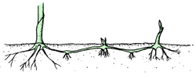
Rhizome – Horizontal, underground stem, typically forms roots and plantlets at tips or nodes. (iris, bentgrass, cannas)
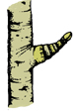

Spur – Very compressed, fruiting twig found on some apples, pears, cherries, and ginkgo.
Twining stems – Modified stems used for climbing. Some twist clockwise (hops, honeysuckle); others twist counter-clockwise (pole beans, Dutchman’s pipe).

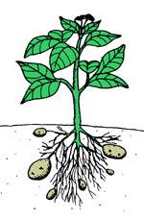
- Tuber – Enlarged rhizome containing stored food. (Irish potato - the eyes of the potato are the modified buds.)

Stems conduct water and minerals from the roots to the leaves.
Stems are found only in vascular plants; that is, plants that have specialized conducting tissues. Seed plants and ferns have stems; mosses do not. Stems provide many useful products, the most important of which is probably wood. (A tree trunk is a stem.) Stems are also the source of tannins, latex, and resins. Edible products that come from stems include sugar from sugarcane, maple syrup, and the white potato. (The potato is an underground stem.) Quinine comes from the bark of the cinchona tree and cinnamon from the bark of the cinnamon tree.
There are basically two different kinds of stems, woody stems and herbaceous stems. Woody stems, found in trees and shrubs, develop substantial amounts of woody tissue and are characteristic of plants that live for many years. Herbaceous stems develop little, if any, woody tissue and are characteristic of plants that live only for one season or plants whose stems die back at the end of a growing season.
Certain types of stems, called modified stems, do not fit the typical description of stems as to form and function. Some modified stems, such as tubers, bulbs, and corms, grow underground. Others, such as stolons and certain kinds of tendrils and thorns, grow aboveground.

