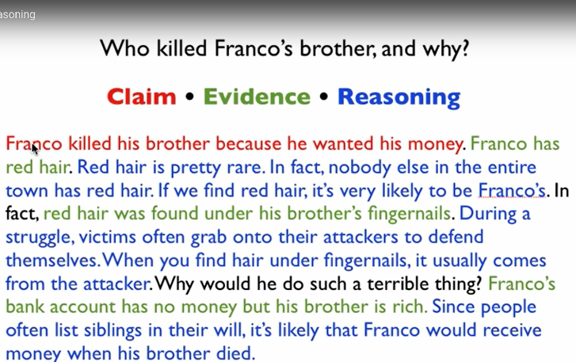
\\hasd-gc-main\dropbox\Mork
Title your document with hour first initial of your first name last name roots
(for example: 1hmorkroots)
Color code the text to Claim, Evidence, Reasoning

