LINES CAN SHOW MOVEMENT AND EYE MOVEMENT IS PREVALANT IN ADVERTIZING
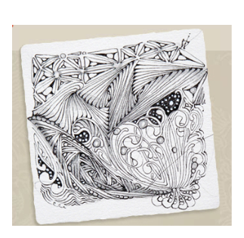
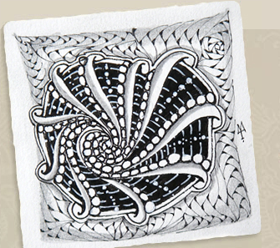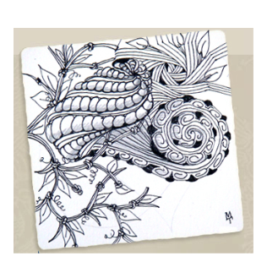
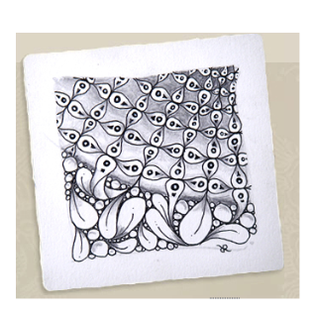
ZENTANGLES
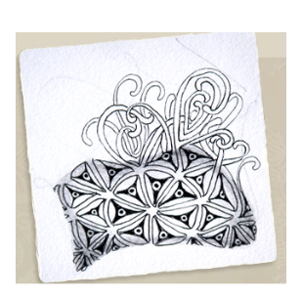
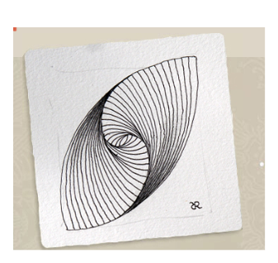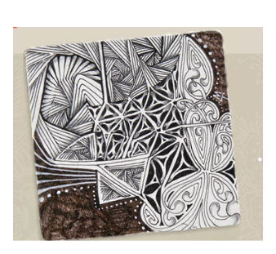
<iframe width="560" height="315" src="http://www.youtube.com/embed/PTdKlc6gXmI" frameborder="0" allowfullscreen></iframe>
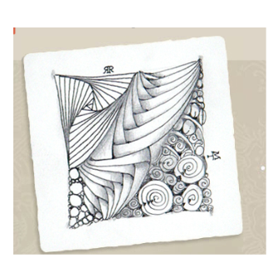
Aura Knot Zentangle 6:22 : http://youtu.be/PTdKlc6gXmI
Mooka; http://youtu.be/0-d2UdXAD7k
Betweed; http://youtu.be/6h0XuK95omE
Peter Draws Zentangle’ish: http://youtu.be/tH5_4dv07MQ
Peter Draws 4 Hour Drawing: http://youtu.be/Ex8BJfy13Z8
Doodling how to get started: http://youtu.be/HRz5ZFDO0hk

Most Intricate Zentangle http://www.youtube.com/watch?v=VyXpqulOjG8&feature=share&list=TL1KZR0y9hjOTY1NYBiR-tngpHZuxawkp-
How to draw tanglepattern W2 and Huggins -----Basket weave http://youtu.be/8DTNVaZsGtM

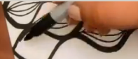 http://youtu.be/E0OuoM2pM_8

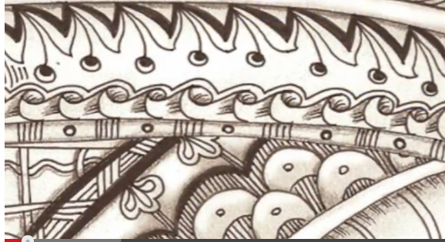 http://youtu.be/I0XeWS_UdhY

